DAY ONE WITH THE BRUSH

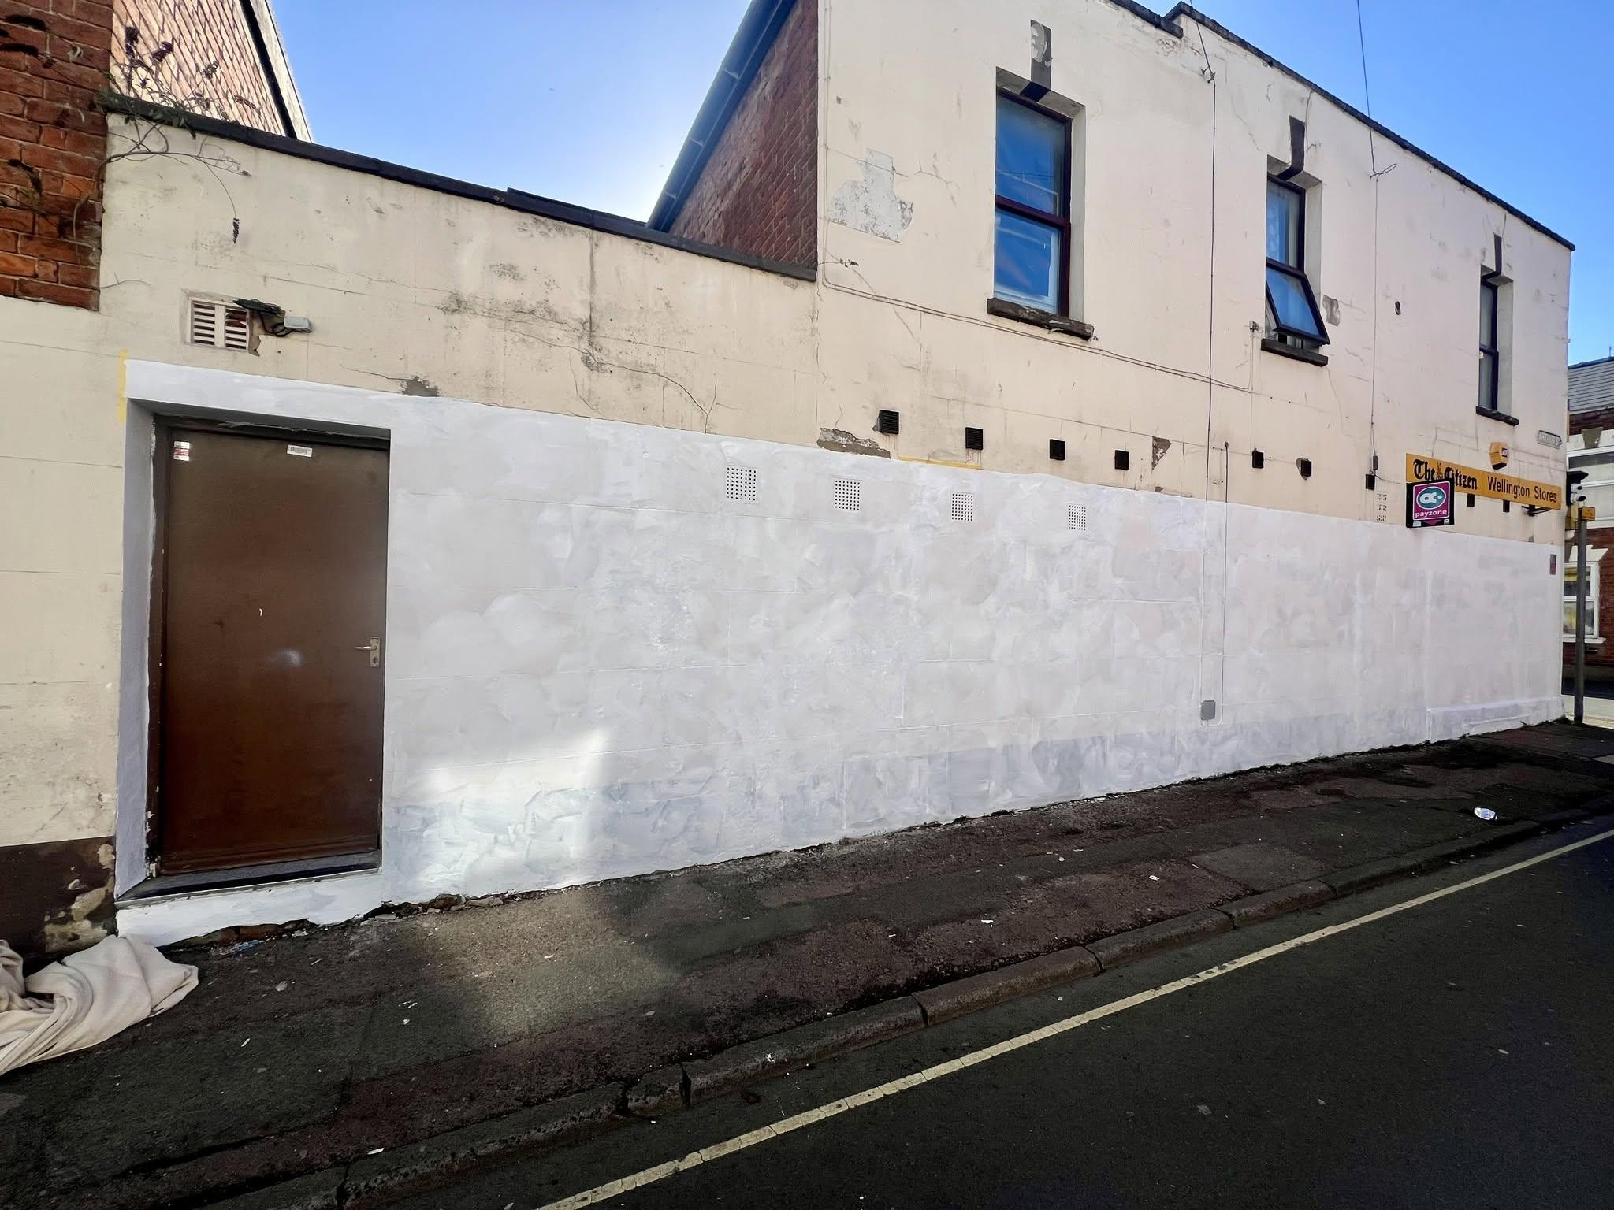
When the temperature rises and the sun comes out all kinds of people are out on the street. Not least mural artists. Today the prime coat for the Voices Gloucester mural - The Man Who Fed The Cats - has been painted.

I was joined on the street today by:
 A group of scaffolders from Bristol (my hometown) working on a house a few doors down - one said loudly on their phone "yeah... I'm in f*cking Gloucester";
 One person cycled past them and said their scaffolding was rubbish (brave);
 A sweet black dog was tied to the post next to me whilst the owner went inside the shop, I tried to talk to her but her eyes were fixed on the door waiting for her owner;
 Many passers by said "thank you" and some who said "come and paint mine when you are done" (ha ha jokes!), one called me "sweetheart" and said he would come back for my number. I hope he wanted a mural and nothing else.
 One lady was shouting a lot and was trying to get someone to answer the door. The scaffolders said they were scared of her (REALLY?)
 Another man came close to me and said "there's some wrong uns round here, mind". Well. He was from "round ere". And I live around the corner. So I would challenge that.

A good first day with the brush.
#gloucester #muralartist #eastgate #gloucesterhistory #gloucesterartsquarter (yes that's what I said)

DAY TWO WITH THE BRUSH
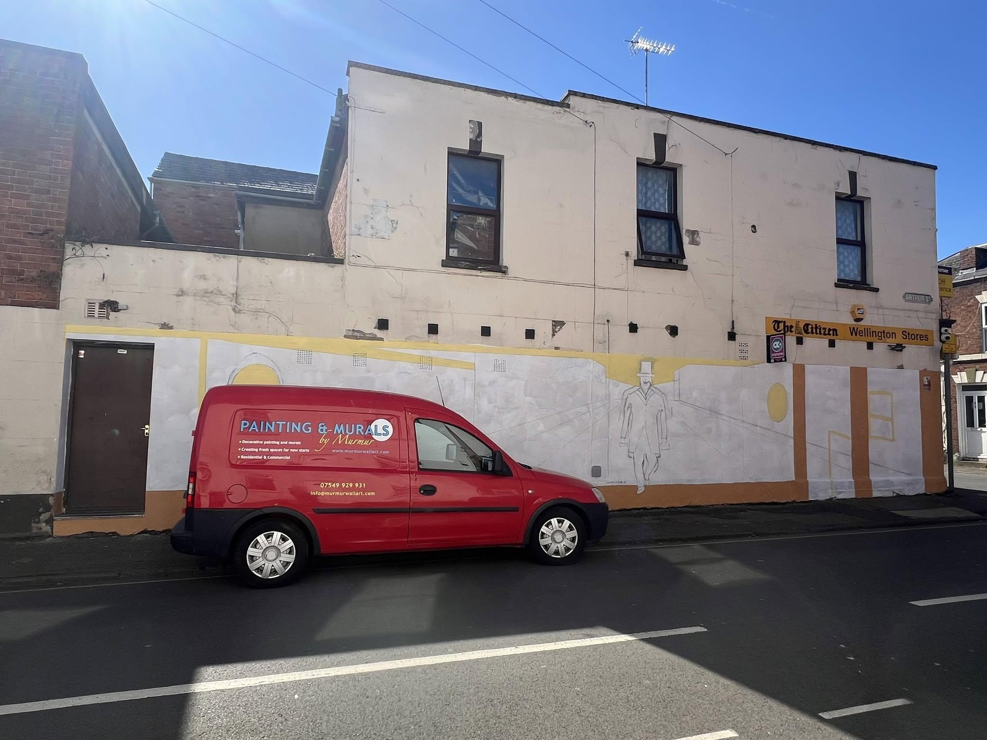
The sun still shines. I'm all sketched out and now the colour begins on the Voices Gloucester mural - The Man Who Fed The Cats.
I was joined on the street today by:
A young Eritrean man on a delivery bike who told me he was also a mural artist. I encouraged him to return with pictures! Fingers crossed he does.
Yesterday's scaffolders gave way to a gang of very polite roofers, who climbed down to ask what I was doing. At one point I overheard them discussing the colour of their underpants (what?)
Several residents came and introduced themselves and thanked me for "making the neighbourhood better". One of them lives opposite - so will have a good view of my finished artwork.
 One resident was disappointed I wasn't painting flowers, but when I told her cats were involved she was very excited and said she would bring child as he "loves cats so much". I now feel like this mural is just for her.
 And thank you to the owner of Wellington Stores for providing the wall and free refreshments today.
Feeling the love and it's only day 2.
#gloucester #muralartist #eastgate #gloucesterhistory #gloucesterartsquarter (yes that's what I said)
DAY THREE WITH THE BRUSH... on the Voices Gloucester mural "The Man who Fed the Cats".
Yes! And I'm getting to pull tape already! 
I did the afternoon shift today and it was quite a different vibe. Less people on their way to work, and more relaxed afternoon strollers about town. Lots of them. They ALL wanted a chat. Today I was joined by:
A man who had moved to Gloucester from London - we discussed how you had the power within to make new starts and turn your life around (deep stuff). He approved of art OUTSIDE the gallery. Amen.
 So many people saying "haven't you finished yet?" (JOKES) It's gonna take flipping weeks.
 More than one older resident who shared long stories of their beloved cats - now passed. One old lady showed me a tattoo of her cat.
 I had a good chat with the folk in the shop who have allowed me to paint - நன்றி - and showed them a picture of me at Elephant Pass (near Jaffna Sri Lanka) taken 25 years ago.
 Some teenager girls wanted to help me paint after I had finished, so I let them pull tape instead.
 One man called me wonderful and asked if I had a boyfriend. I said I had a husband, just round the corner. He said we must be both angels and love each other very much. All true.
 One guy came up close and whispered "I am a graffiti artist". I asked him if he was Banksy and he winked and walked off. I like to think he was Banksy's grandson.
 And I met lots of my lovely neighbours from St Bartholomew's - some of whom knew my naughty cat better than they knew me!
#gloucester #muralartist #eastgate #gloucesterhistory #gloucesterartsquarter (yes that's what I said)

DAY FOUR WITH THE BRUSH... and the Voices Gloucester mural "The Man who Fed the Cats" is taking shape.
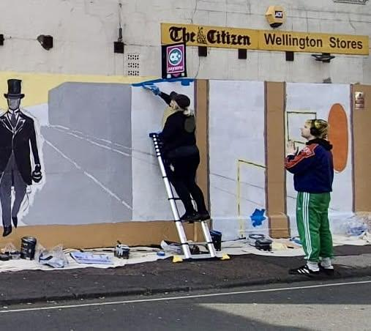
I had help today from two special friends - including the fabulously skilled Ugly (who normally paints faces not walls).
 People were driving past filming me paint this afternoon (what?) and there were lots of repeat visitors checking to see how it was going. So much encouragement and thanks, especially from the smartly dressed church goers.
 A young brother and sister got excited to talk about vanishing points - they said had learnt about it at school.
One guy got quite excited by the idea that cats would be involved in the artwork and said "pussy" rather too many times.
#gloucester #muralartist #eastgate #gloucesterhistory #gloucesterartsquarter (yes that's what I said)

DAY FIVE WITH THE BRUSH (and the spray can)... and Ralph Fletcher himself is starting to appear. I can't wait for his furry friends to join him.
With the help of @vince_ugly the secret second site for mural 2 was also prepped ready for a bit of render fixing.
I had a long chat with a heroin addict today (how he introduced himself). We spoke about art, his time in prison, and intergenerational trauma. He said he had been having a really shit day and I turned it around for him. Happy to help.
 One lady shouted "that painting cheers me up every day now!"
 A very tall drunk man decided he needed to hug me - which was a bit unpleasant. Vince was having none of it.
 A kind lady close to the second site has offered daily use of her toilet. That will come in very handy. How lovely people are.
Lots of photos being taken... which is nice, but as an artist it's uncomfortable people judging it before it's finished.
Voices Gloucester #TheManwhoFedtheCats
#gloucester #muralartist #eastgate #gloucesterhistory #gloucesterartsquarter (yes that's what I said)
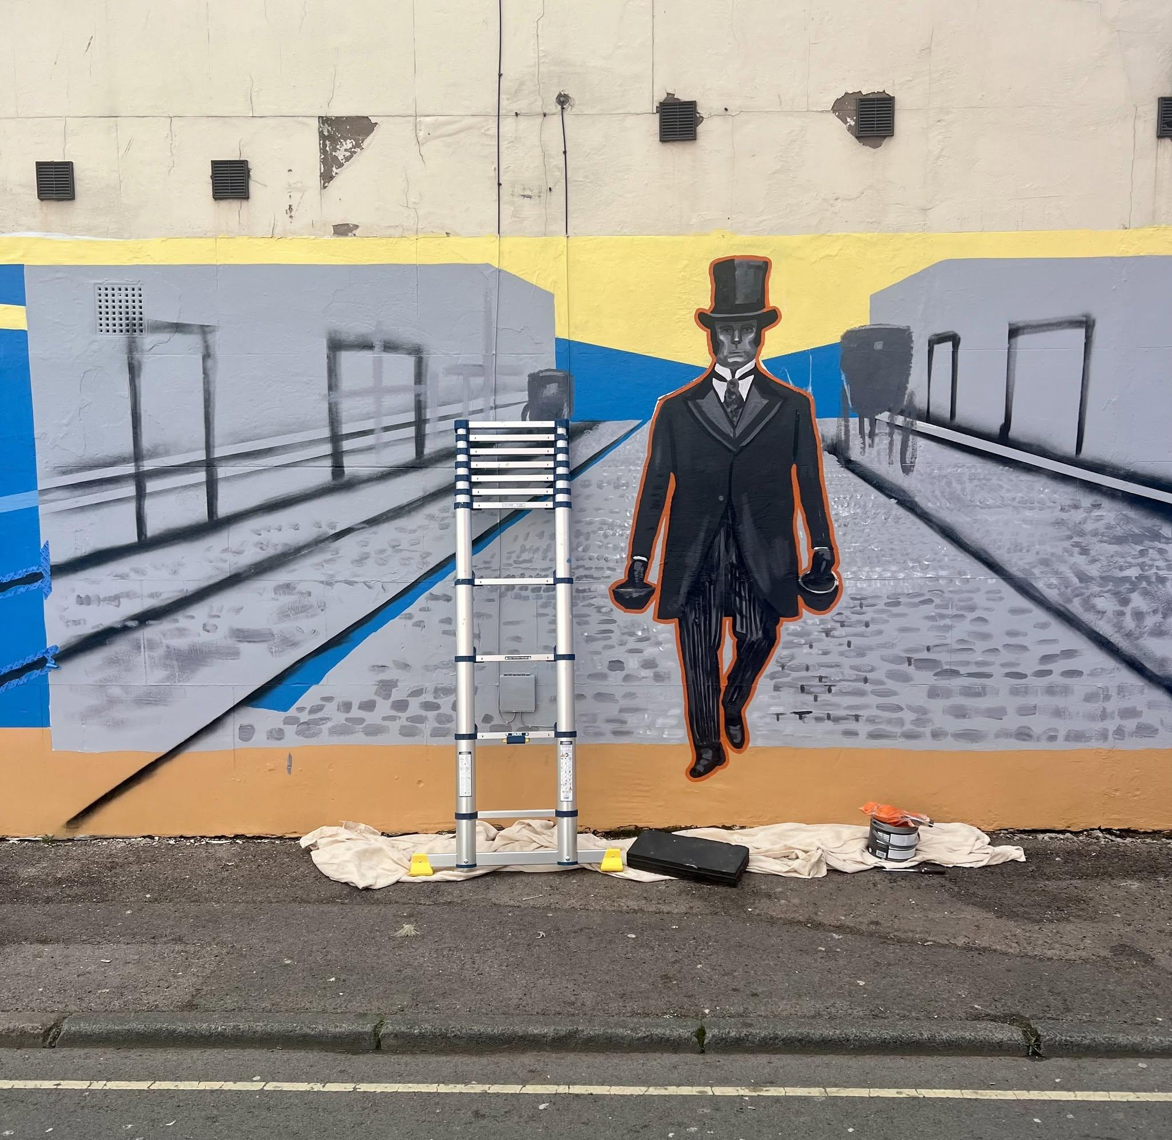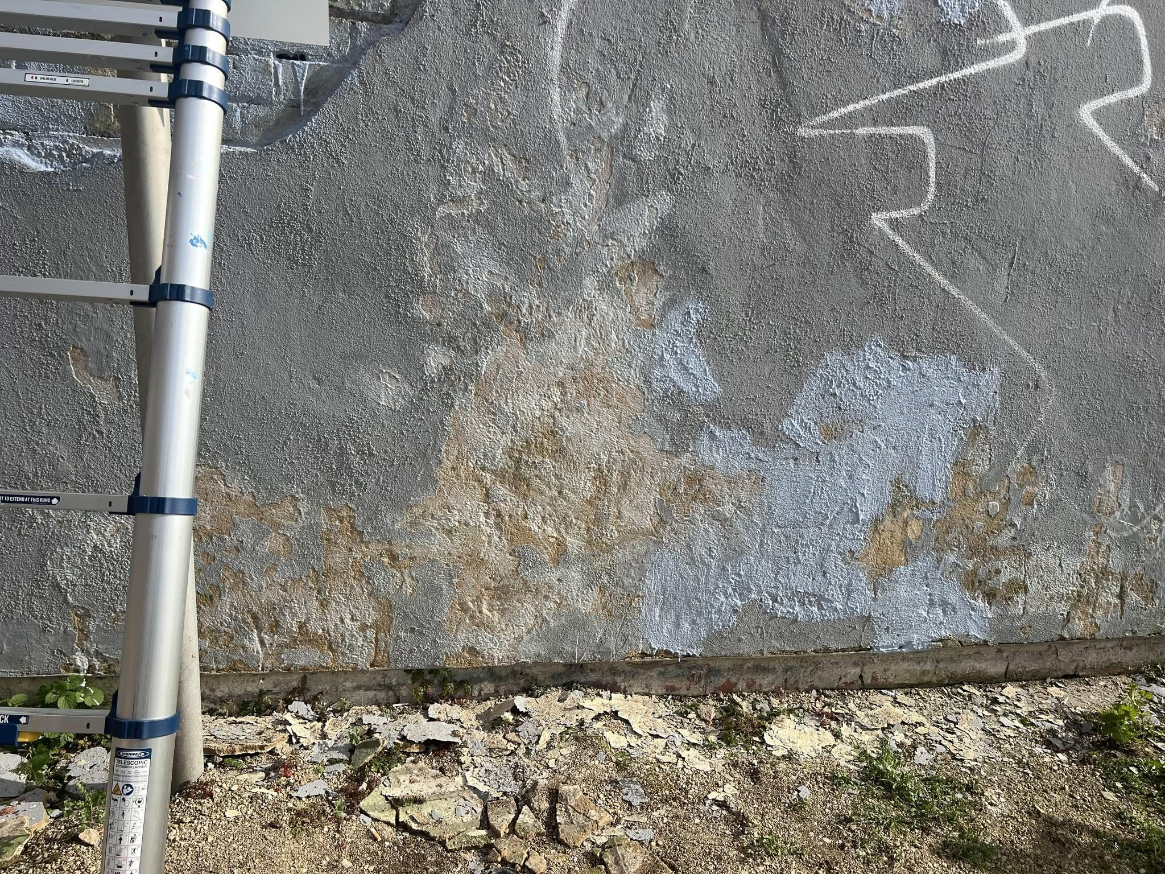

DAY SIX WITH THE SPRAY CAN… on “The man who fed the cats”
I only managed 2 hours working the spray paint into the Victorian Street scene to create texture. But on my own, so many more people said hello or stopped for a chat.
On the street today:
 Several cars stopped, some holding up traffic, to ask just what was going on here.
People have started using my name. I overheard several saying things like “oh yes…I spoke to this lady… this is going to be lots of cats and a mayor”
A young man in a tracksuit leaned close: “so you are the artist. Secret safe with me” He winked.
 Lovely black dog from day 1 returned. Still not interested in a hello.
#muralartist #eastgate #gloucesterhistory #gloucesterartsquarter (yes that's what I said)
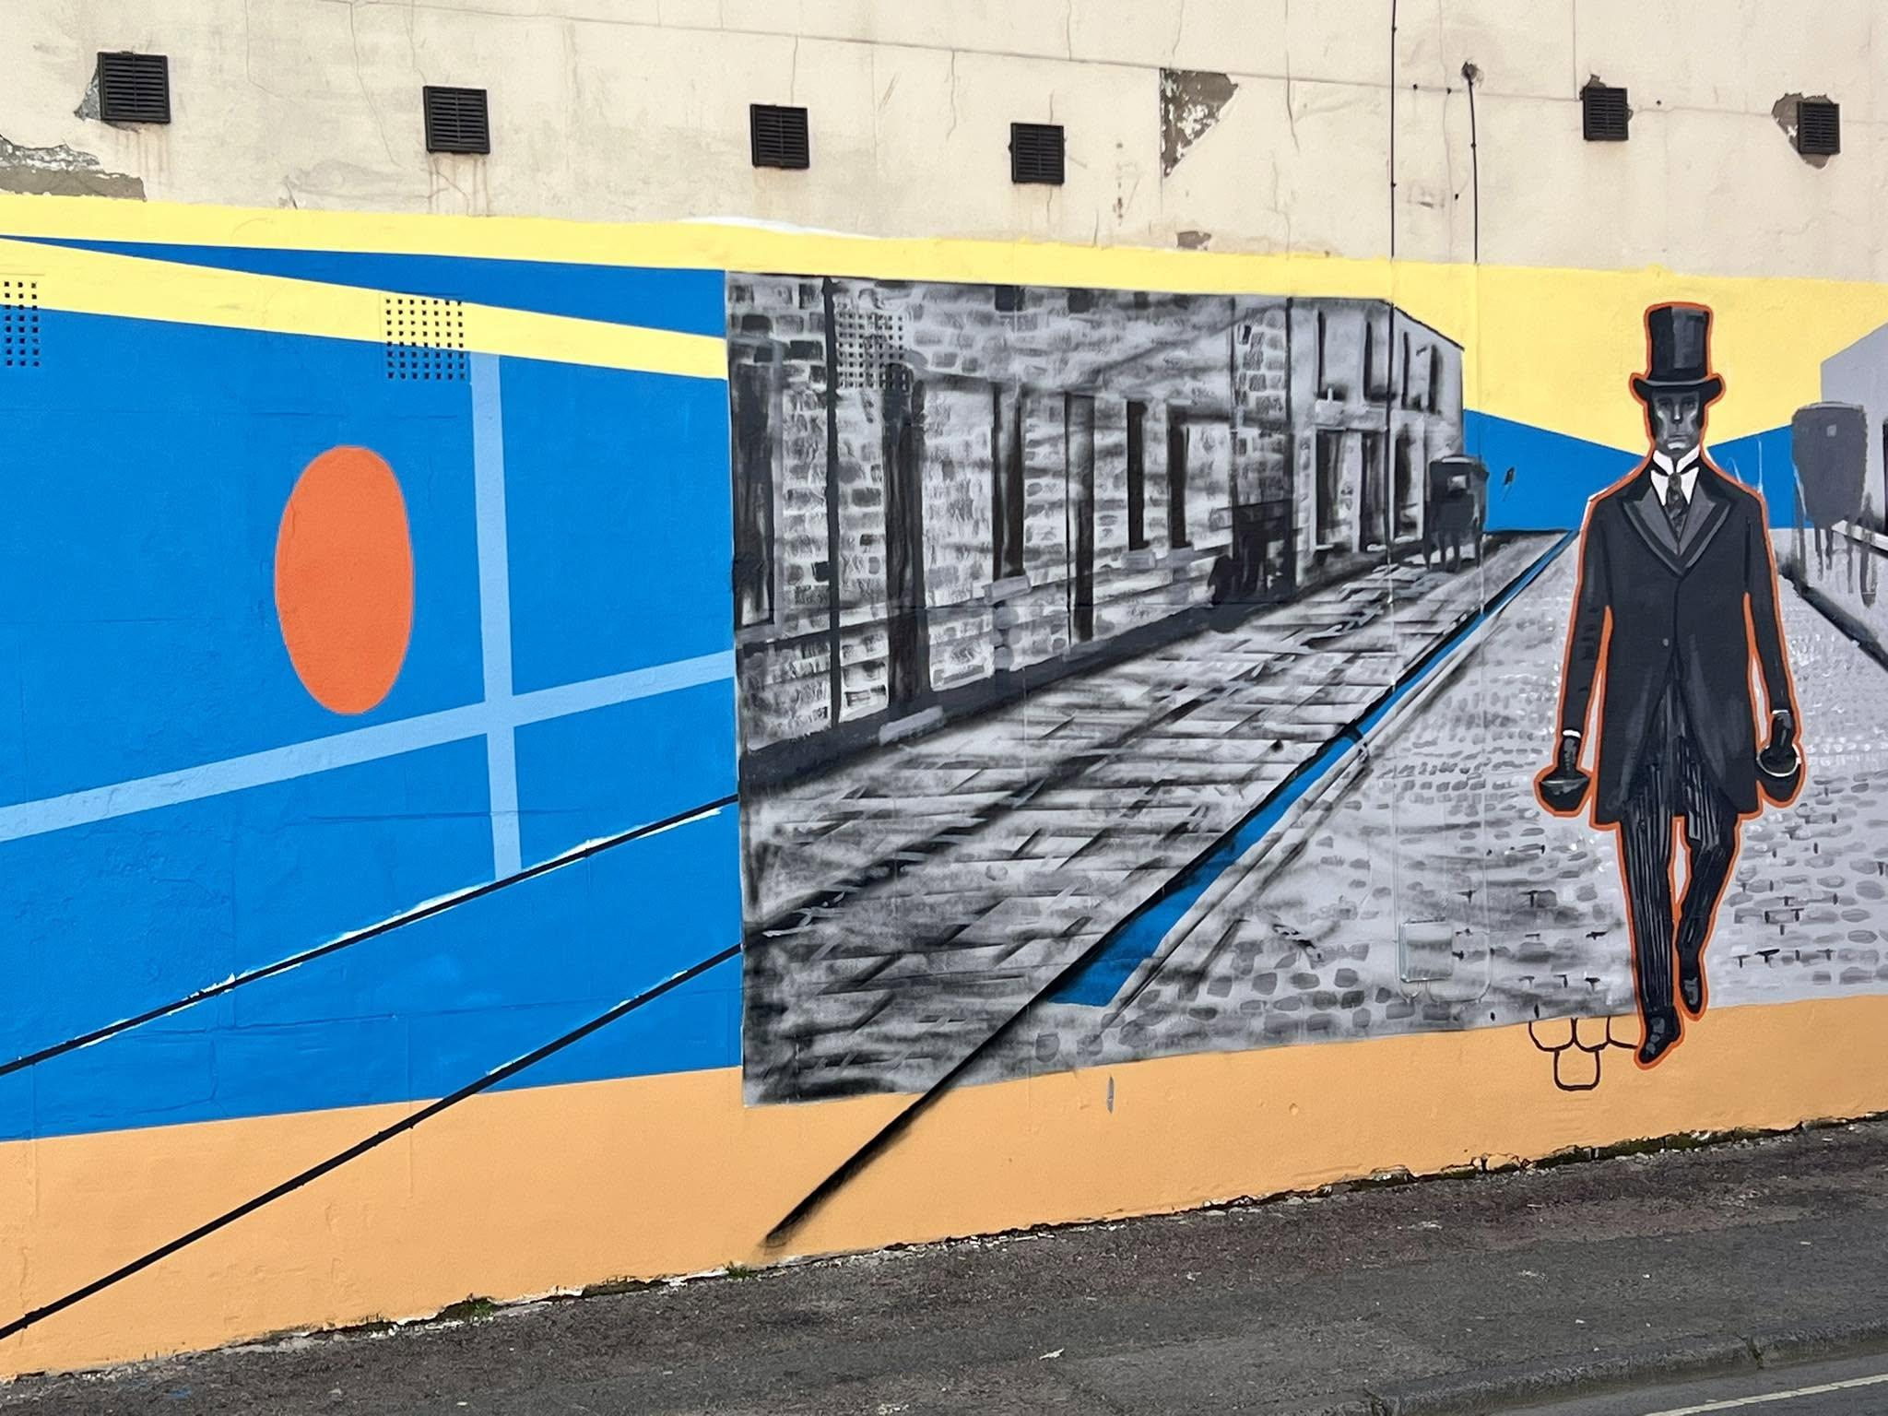

DAY SEVEN WITH THE BRUSH and it feels like we might be nearly ready of some cats and some explanation! 
Today on the street:
A man with an impressive beard showed me his art work on trainers, hats and in his sketchbooks he had a big suitcase.
The Seventh Day adventists were back - dressed in smart clothes and offering praise and magazines.
A JustEat delivery driver asked me to paint a mural in his house of a portrait of someone he had lost. We spent a long time talking and he was impressed by the story of Ralph.
Our favourite neighbour visited on his mobility scooter bringing more photos of his white cat. Another regular visitor suggested more white cats should be added to the mural.
 Lots of thankyous and well dones from passers by.
Someone suggested Ralph looked like a peaky blinder. Two traffic wardens thought he was Sherlock Holmes. One man shouted “Isambard Kingdom Brunel” at me.
Not long to go now. Today was a tough stint even with help from my partner in crime/art.

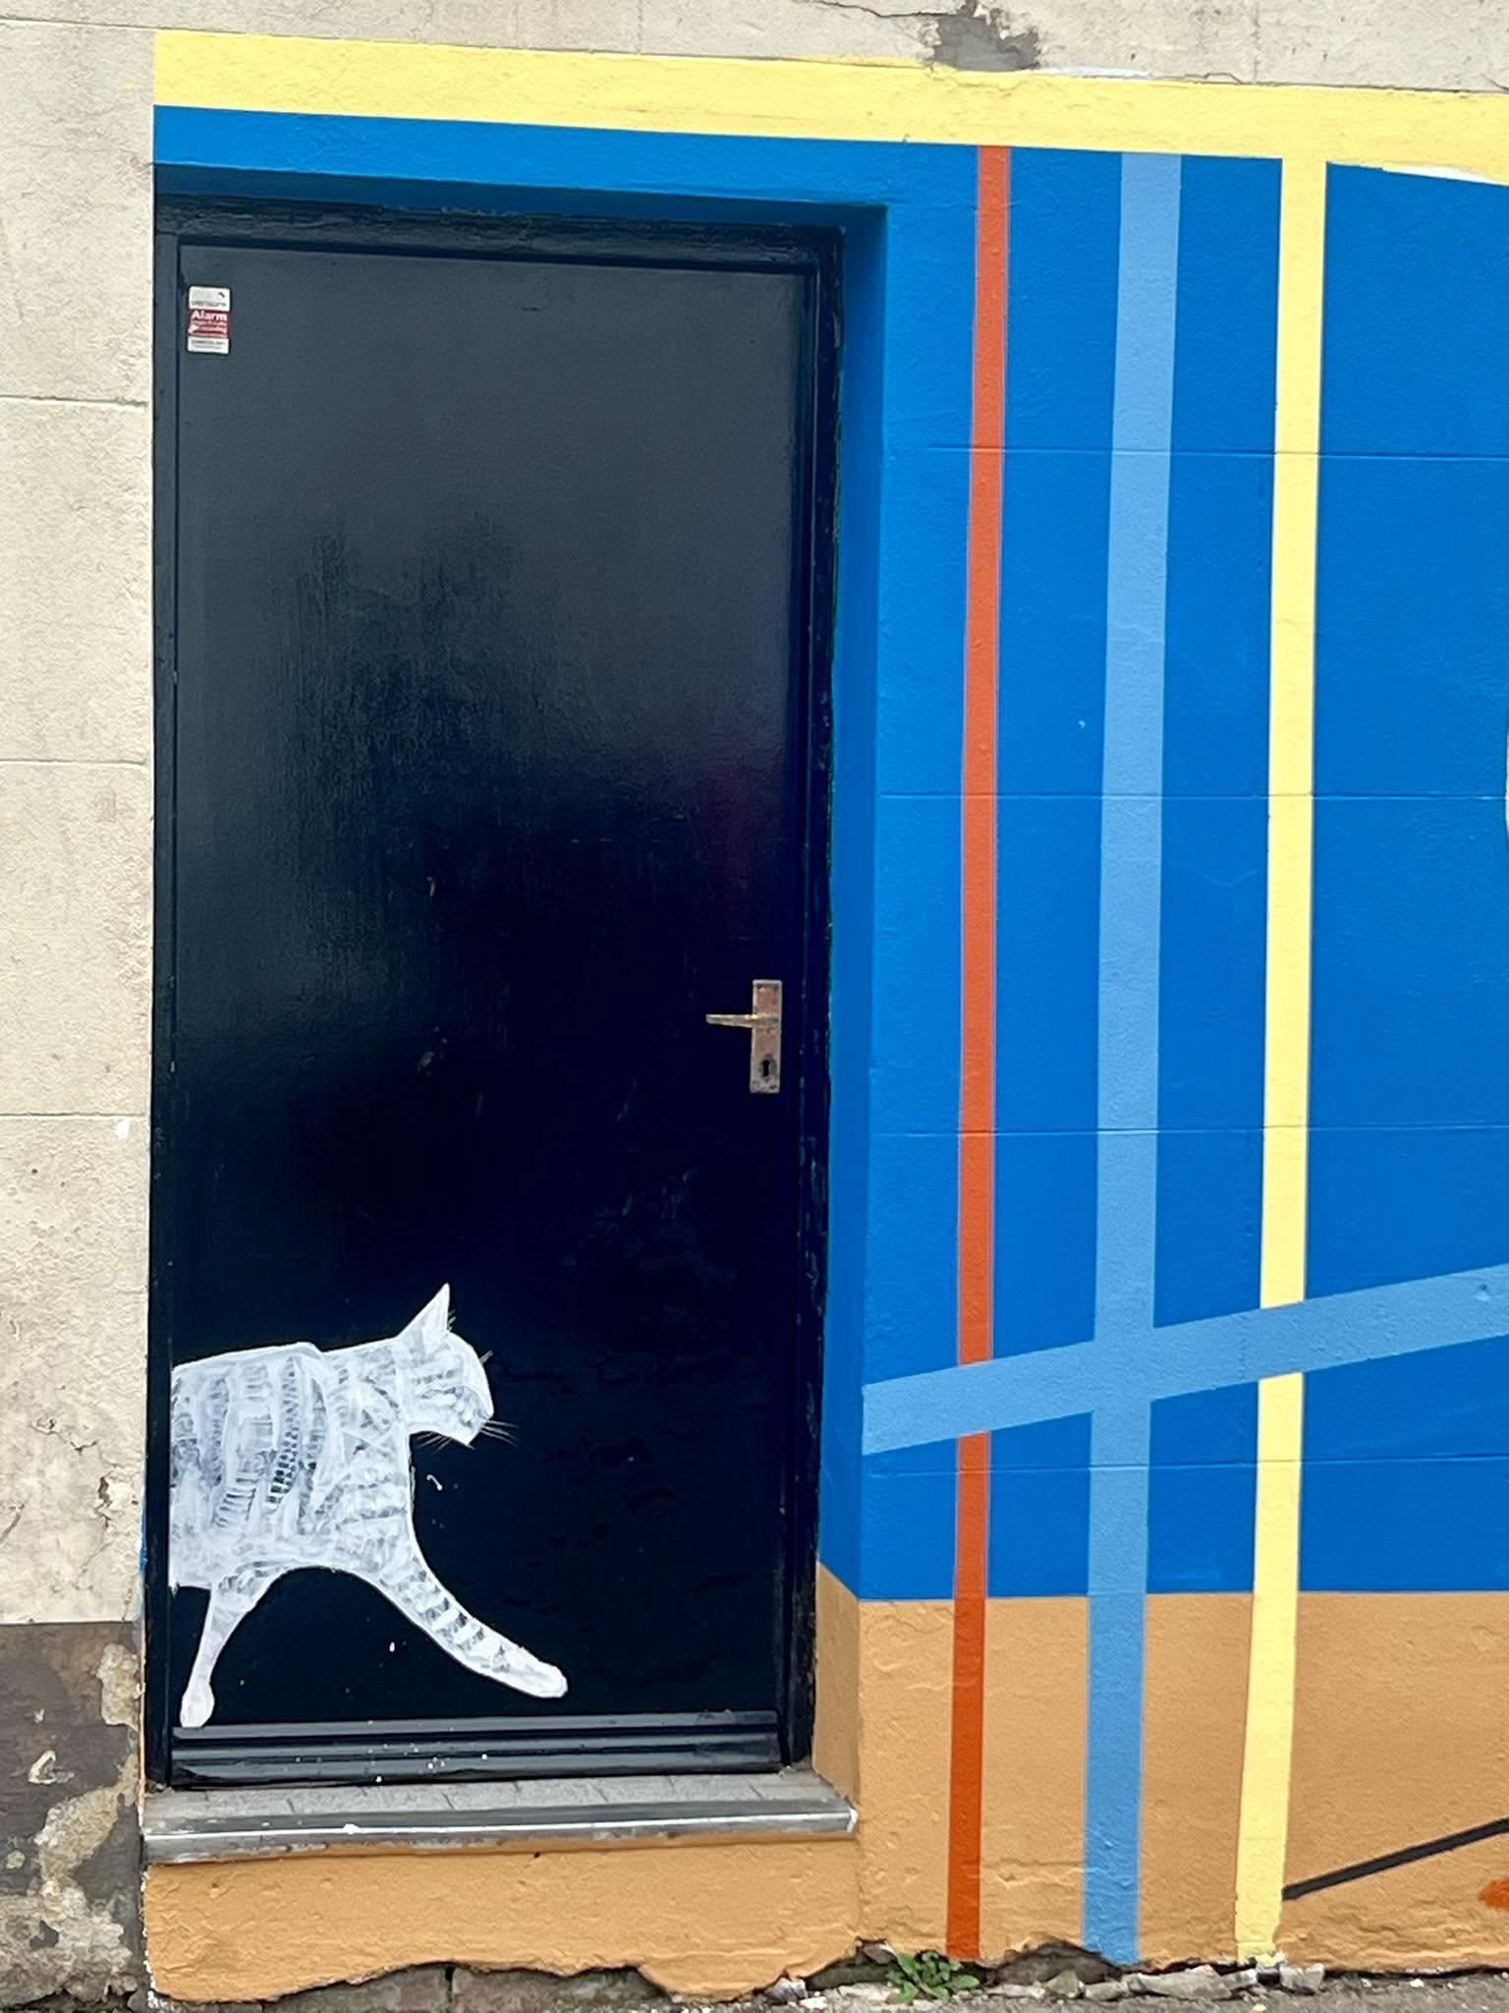
DAY EIGHT WITH THE BRUSH (& CHARCOAL) on "The Man Who Fed the Cats" heritage mural funded by Voices Gloucester.
I sketched cats mostly today, whilst my partner painted the final background lines. But today was really about John.
🐣 John has a view of the mural from his window. And his window is very well known in the local area for his quirky seasonal displays. Today was Easter Sunday - and his display did not disappoint. John came to introduce himself for the first time and bought with him a painting made by his daughter when she was little. He said the picture had won a prize and although his daughter didn't like the painting anymore, he cherished it. He didn't know who the portrait was of - and although what the person is wearing in the image pre-dates the sort of thing our Ralph Fletcher would have worn - I like to think that it maybe one of Ralph's ancestors.
🏎️ Just as we were packing up, John came back with a photo album of his life, including evidence that he once delivered coal for a living; had been in the army; had raced cars; and believe it or not was once a drag queen called "Amanda".
❤️ I love my street encounters. It's made this work so very special. Day EIGHT will be later in the month as I'm hanging up by paint brush for a rest. There's not long to go on this mural - and plenty of time to get excited for the sister mural across town.
#muralartist #gloucesterartsquarter #gloucester #gloucesterhistory #ilovegloucester
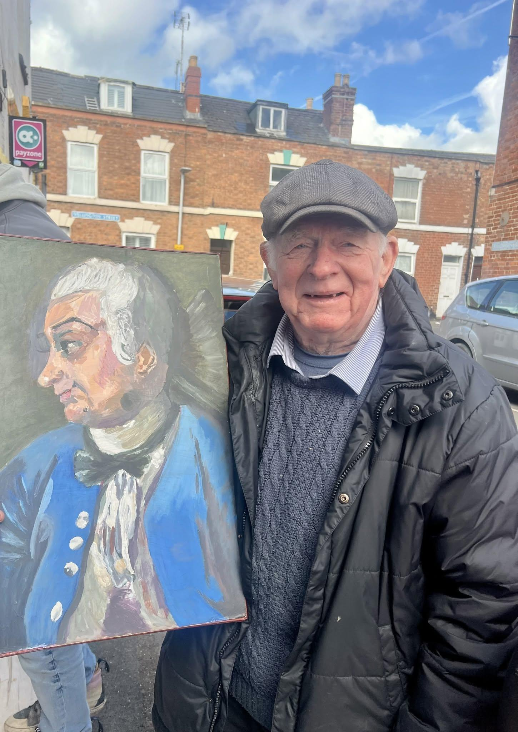

DAY NINE ON THE BRUSH - and rain stopped play after just a couple of hours. I painted 27 cats nonetheless.
I was joined on the street today by several close neighbours who stayed for long chats.
One young man with no shoes told me he was looking forward to seeing the finished work “every single day”. He told me about his dog - a rescue with a muzzle that I must approach if I’m walking my dog. Noted.
One older man from Gujarat told me all about his cat who likes to disappear and loves his grandson.
Hopefully back to finish cats in the morning - weather permitting.
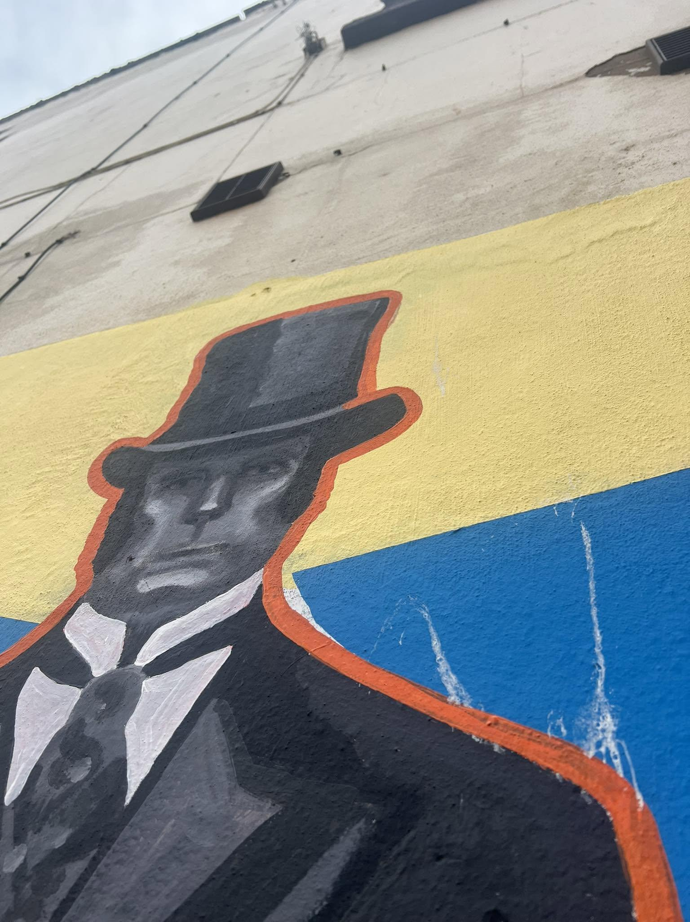

DAY TEN WITH THE BRUSH…I snuck out early briefly before most people were up. I heard alarm clocks going off in houses and half asleep people staggered to Wellington Stores for milk for their coffee.
But one person was coming home from work as a cleaner and told me all about their new born son called King. Beautiful.
Some of you may recognise “Luna Macka” from my mural “Cats’ Corner” at the start of High Street, Tredworth. Again escaping from a circle.
Not long to go on this mural now… before I start the next across town.
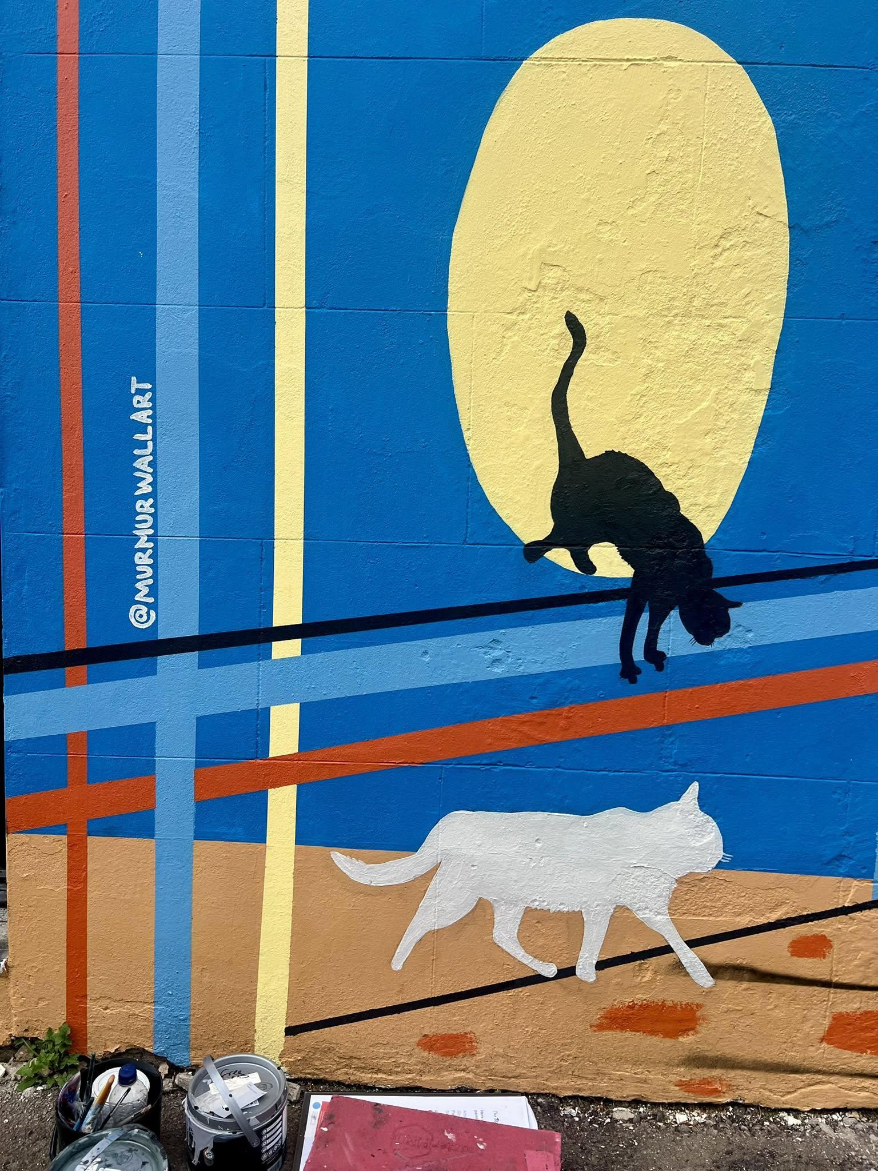

DAY ELEVEN WITH THE BRUSH on the Voices Gloucester funded "The Man Who Fed the Cats"...

🖌️ I was brush-in-hand at 7am for a bright and sunny start... today was my final day on this wall. Kind of sad. Kind of happy. I will miss the wonderfully friendly and encouraging passers by, and the stories that each day brought.

🛒 But I am looking forward to making a start on the second mural in this project across town. I might need to get myself a trolley to lug my paint as the second one is not quite as close to my home.

🧭 For those who want to have a sneaky look at my handiwork, before both murals are launched together, visit Wellington Stores in Gloucester (corner of Wellington and Arthur Street) What3words /// plan.swing.first . Everyone is welcome apart from seagulls who keep crapping on it.

🐈‍⬛"This is one of two murals in Gloucester that commemorate former Mayor of this city Ralph Fletcher who lived close to here between 1780 -1851. He was an early animal welfare champion: when he died he left a trust fund to feed stray cats; he tipped a shilling to the owners of well looked after horses; and he wrote one of the first papers on the prevention of cruelty to animals"

Heritagefund Gloucester BID Gloucestershire Heritage Hub Gloucestershire Live BBC Gloucestershire

#gloucester #gloucesterartsquarter #muralart #heritagemural #murmurwallart
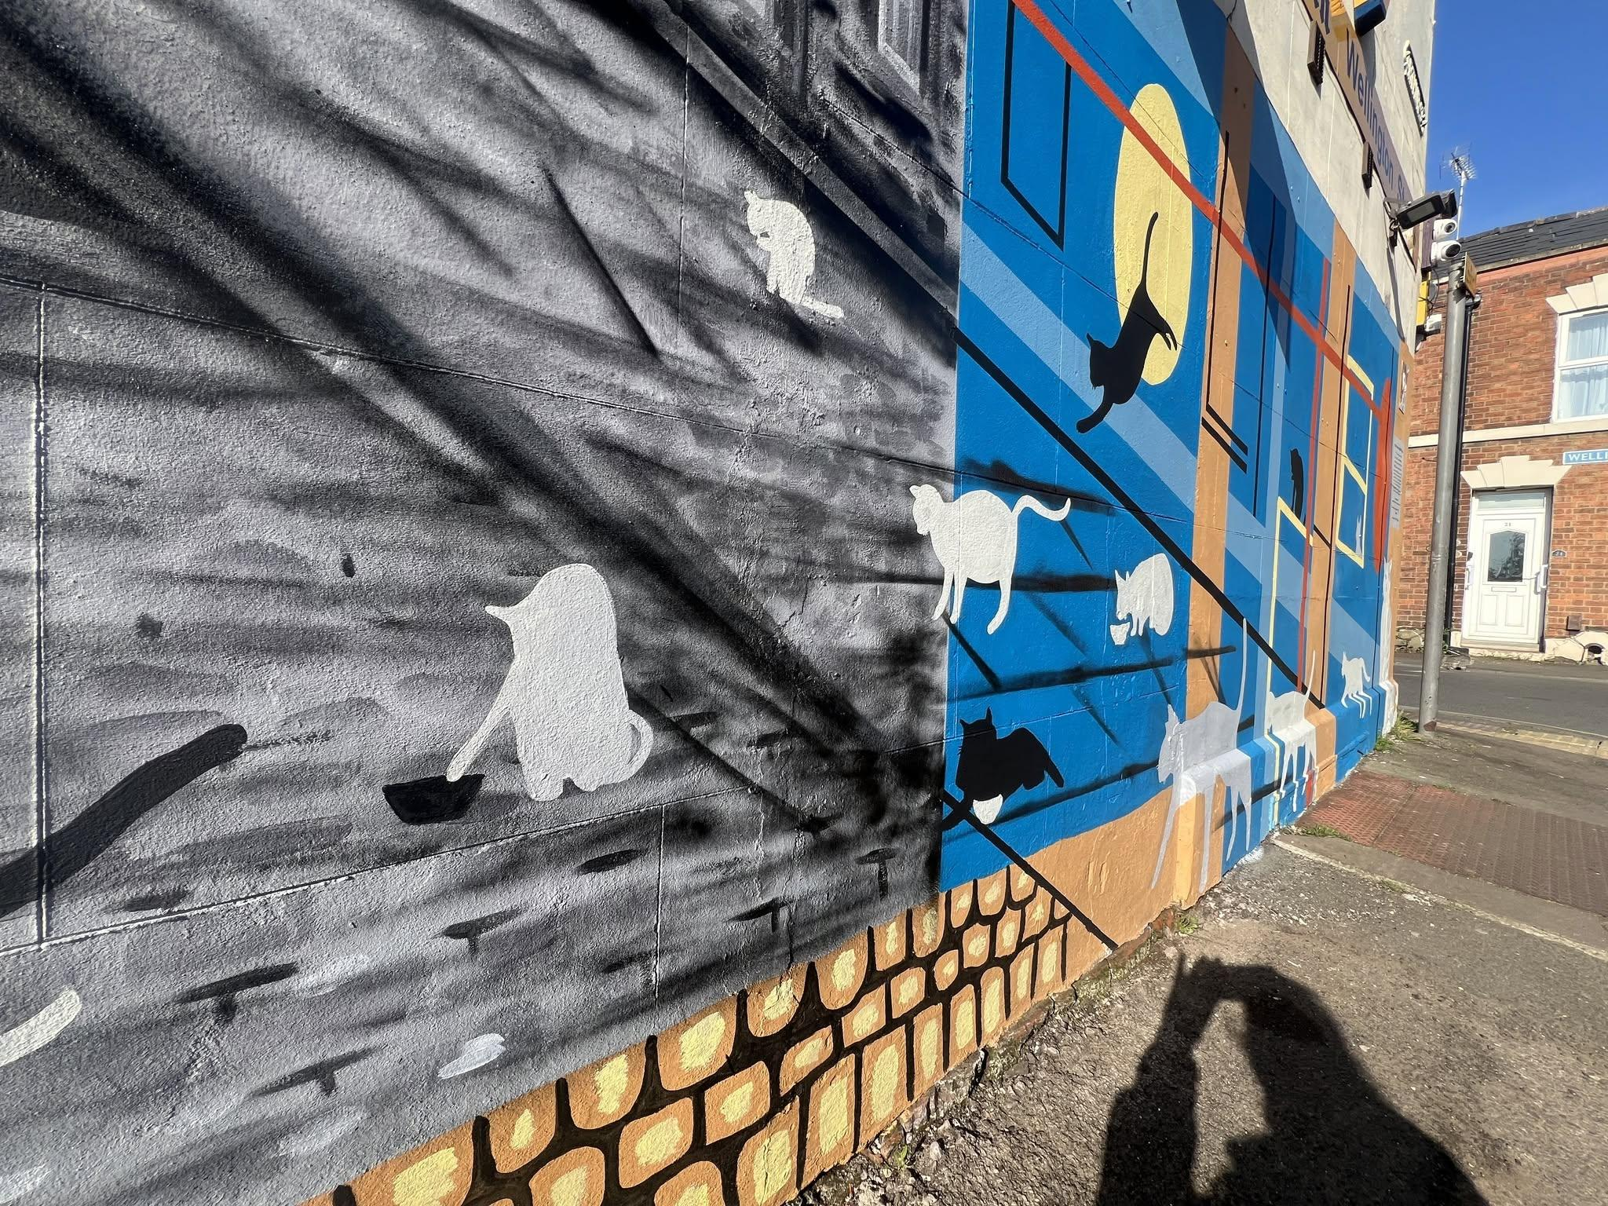

DAY ONE WITH THE BRUSH: Finally! After hot weather, rainy weather, render repairs, and parked cars…
…we were able to get some paint on the wall for “The Man Who Fed The Cats” (part 2: “the thank you”).
 The black surround that’s gone on today and the beginning of a primer coat are just the very beginning of another mural story.
Today on the street:
 Early on a Sunday morning the streets were quite empty. Some runners with medals ambled around having completed the 10k race.
 A French family passed by having an argument (today’s painting assistant speaks French which is how we knew)
 A handful of people arrived for a band practice in the church building we are painting on. We couldn’t recognise the language they were singing, but beautiful voices flowed out through open windows for over an hour.
Moments before I started painting a giant slurry of seagull poo landed on my arm. Beautiful. I’ll count that as lucky
 Groups of churchgoers later arrived, hanging around on the pavement, smoking and laughing. Some of the younger ones were speaking English. They all looked very smart in suits and one man was explaining his ironing routine. All I had painted was a band of black and a bit of primer, but they were nodding encouragingly, saying “good, good” and giving me the thumbs up.
 The guy who works for NCP arrived, and said he knew mural 1 on Arthur/Wellington street and was excited to see mural 2. I said a big thank you to him for arranging for the removal of a large NCP sign which would have blocked the view of the mural.

 DAY TWO WITH THE BRUSH: I had soooo much help today getting this mural back up to speed. Not one, but two lovely assistants helping with the background painting.
 Not only did we paint, but we filled a bin liner with litter from the site. We are going to need the weeds cutting right back once the mural is done…. Any volunteers?
Today’s gems from the street included:
Another lively interaction with the church goers. Turns out they are a “Czechoslovak” community (yep, still exists). More lovely songs and some of the youngsters were keen to explain their own creativity. One had recently painted a picture of Deadpool and said he would help but he didn’t want to get paint in his lovely suit. It didn’t stop him pulling tape off the painted edge though. #bestjob
Two sisters stopped to ask me what I was doing and enjoyed learning about Ralph Fletcher “The Man Who Fed The Cats”. One said she would have preferred dogs. The other lived in Montpelier in France and they were off to do sisterly shopping at the Quays. We saw them a few hours later with armfuls of shopping wacing happy hellos.
Lots more hellos and well dones throughout the day. Plus a visit from my family. What a lovely day.
Next. Things get real as I begin the mamouth task of 34 pet portraits
#muralart #streetart #murmurartist #gloucester
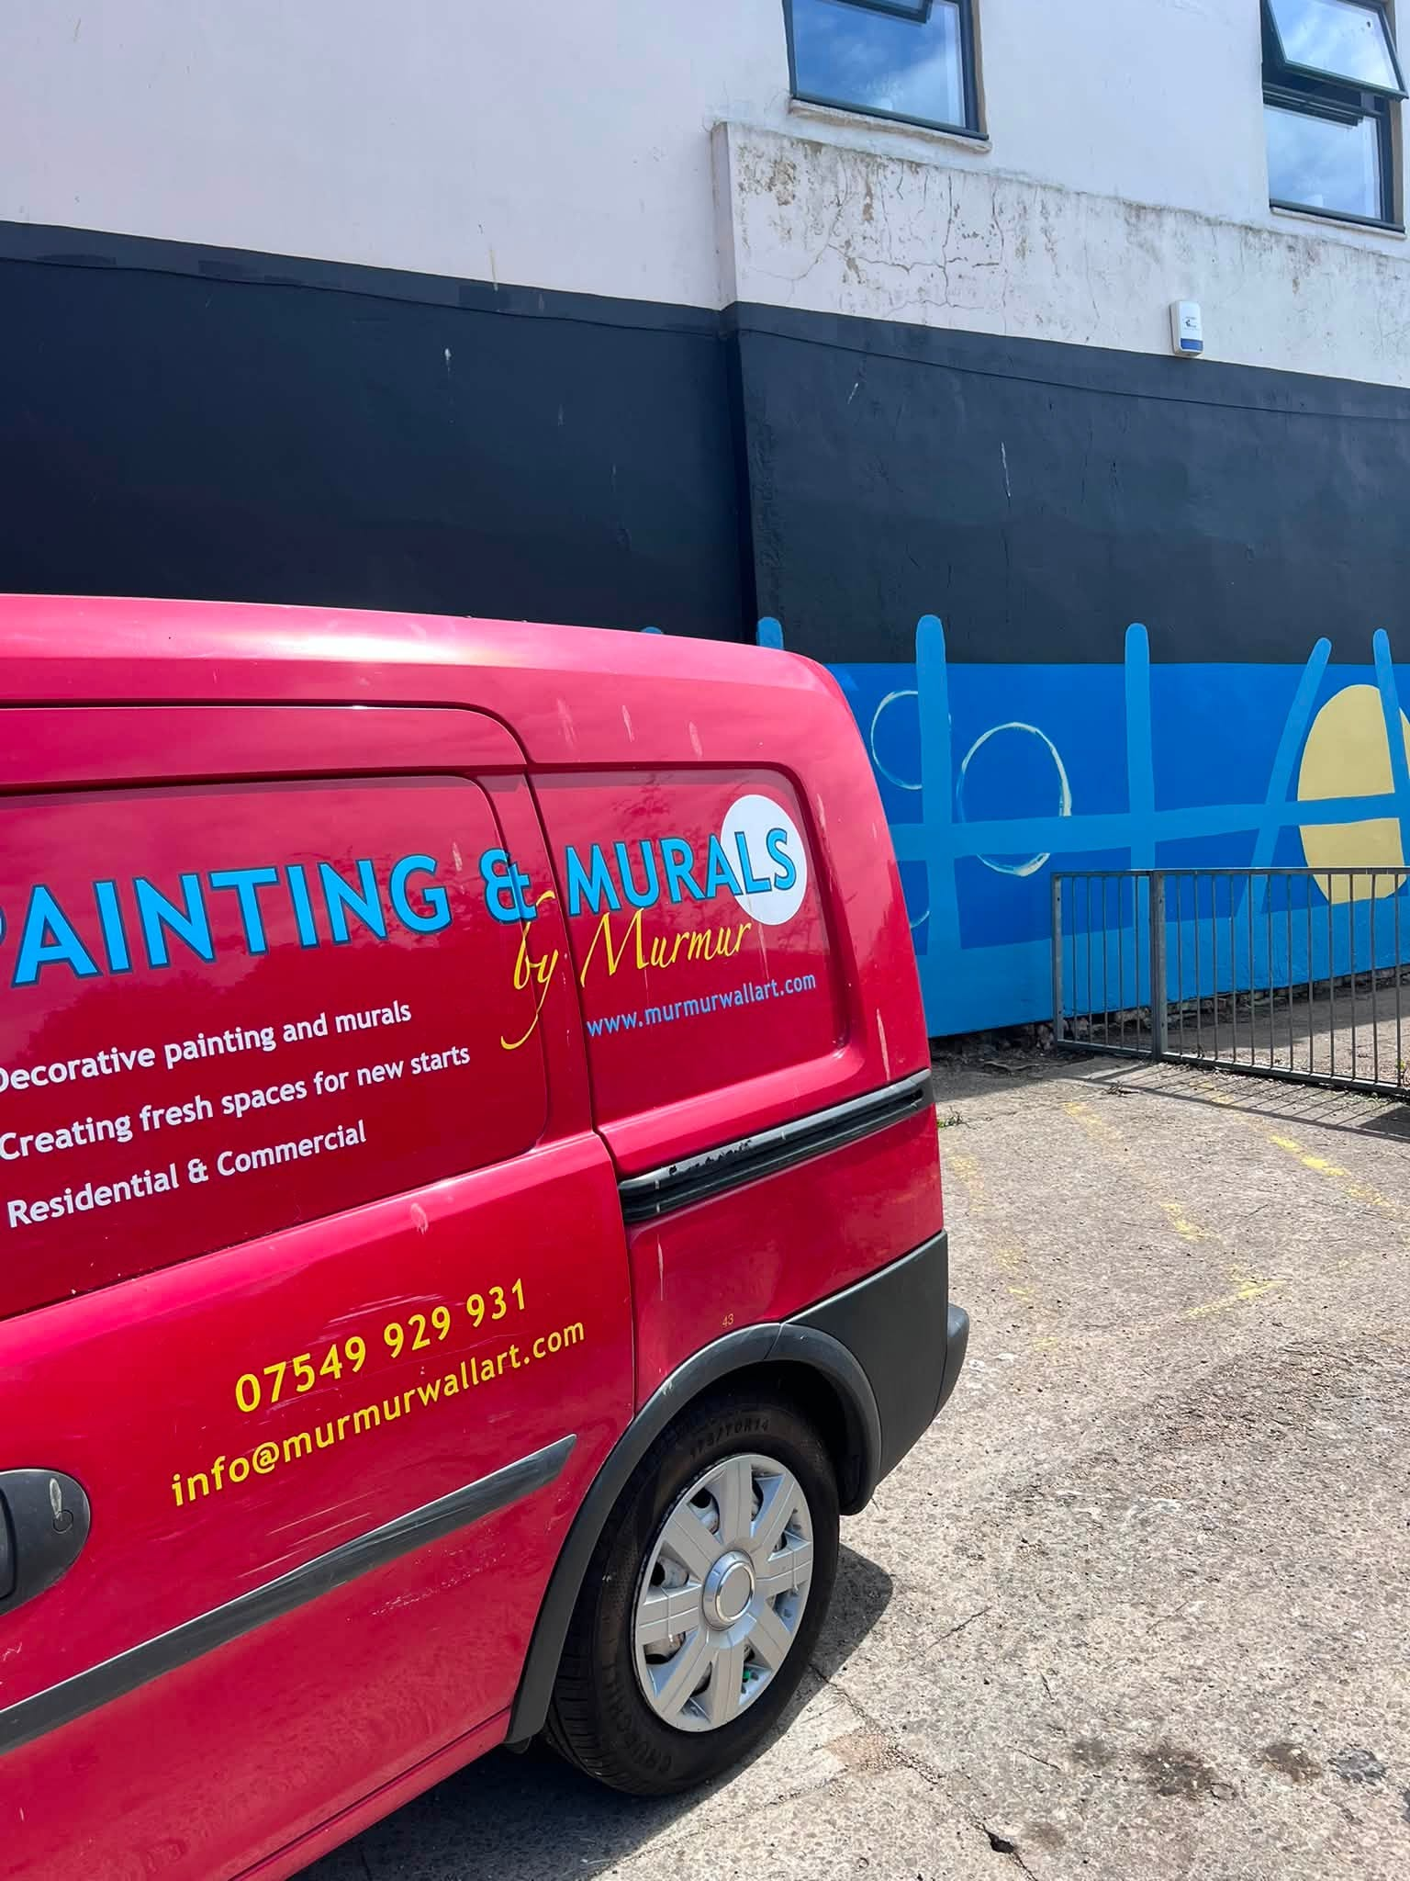

DAY THREE WITH THE SPRAY CAN on the Gloucester city centre mural “The Man Who Fed The Cats” (part 2 - thank you) funded by Voices Gloucester
It’s 28 degrees out there and some masonry paint doesn’t like that. So I took to the spray can and created the 34 circular frames - one for each memorial pet portrait.
Here’s something I noticed. NOBODY talks to you when you have a spray can in your hand. Not even a hello. But hold a paint brush and everyone is your friend.
My next day on this wall (when it’s cooled down a bit) will be with a brush. Making proper art - not just random shapes.
#paintbrushdiplomacy
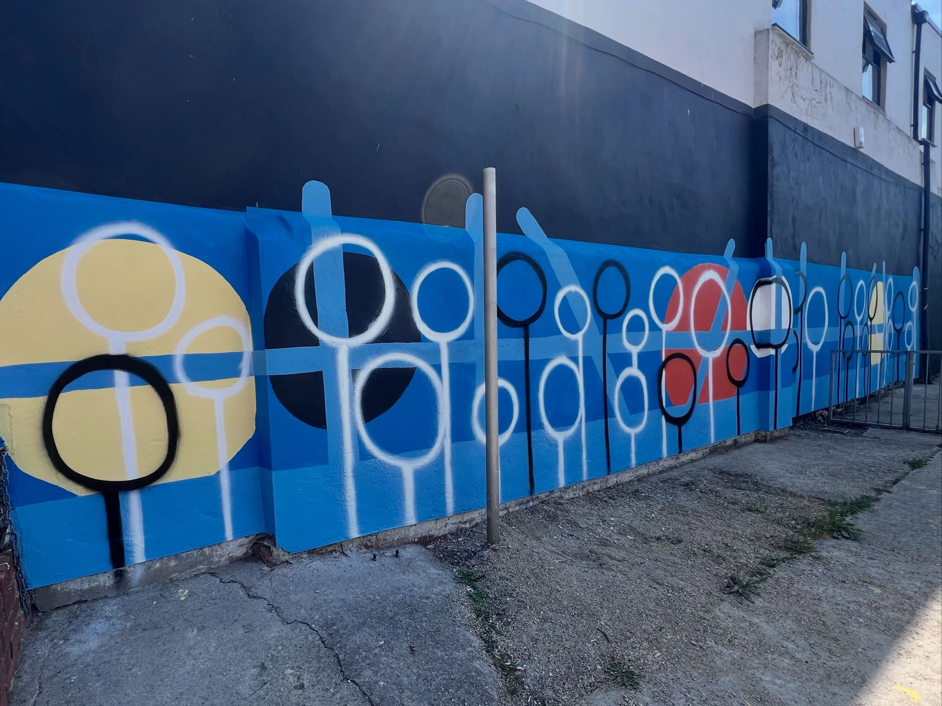

DAY FOUR WITH THE BRUSH: Say hello to Mitsy, Lisa, Muffin and Rosie! The first four cherished Gloucester pets to arrive on the wall.
Early on a Sunday morning, and working behind a railing, I had absolutely no conversation with anyone.
The usual Czechoslovak churchgoers were out of ear and voice range.
Those parking cars and walking by did not see me.
It was actually quite nice. I really got in the zone and felt quite close to these four creatures as I celebrated their lives.
Only 30 more pets to paint!
#themanwhofedthecats Voices Gloucester BBC Gloucestershire Gloucester BID #gloucester #muralart
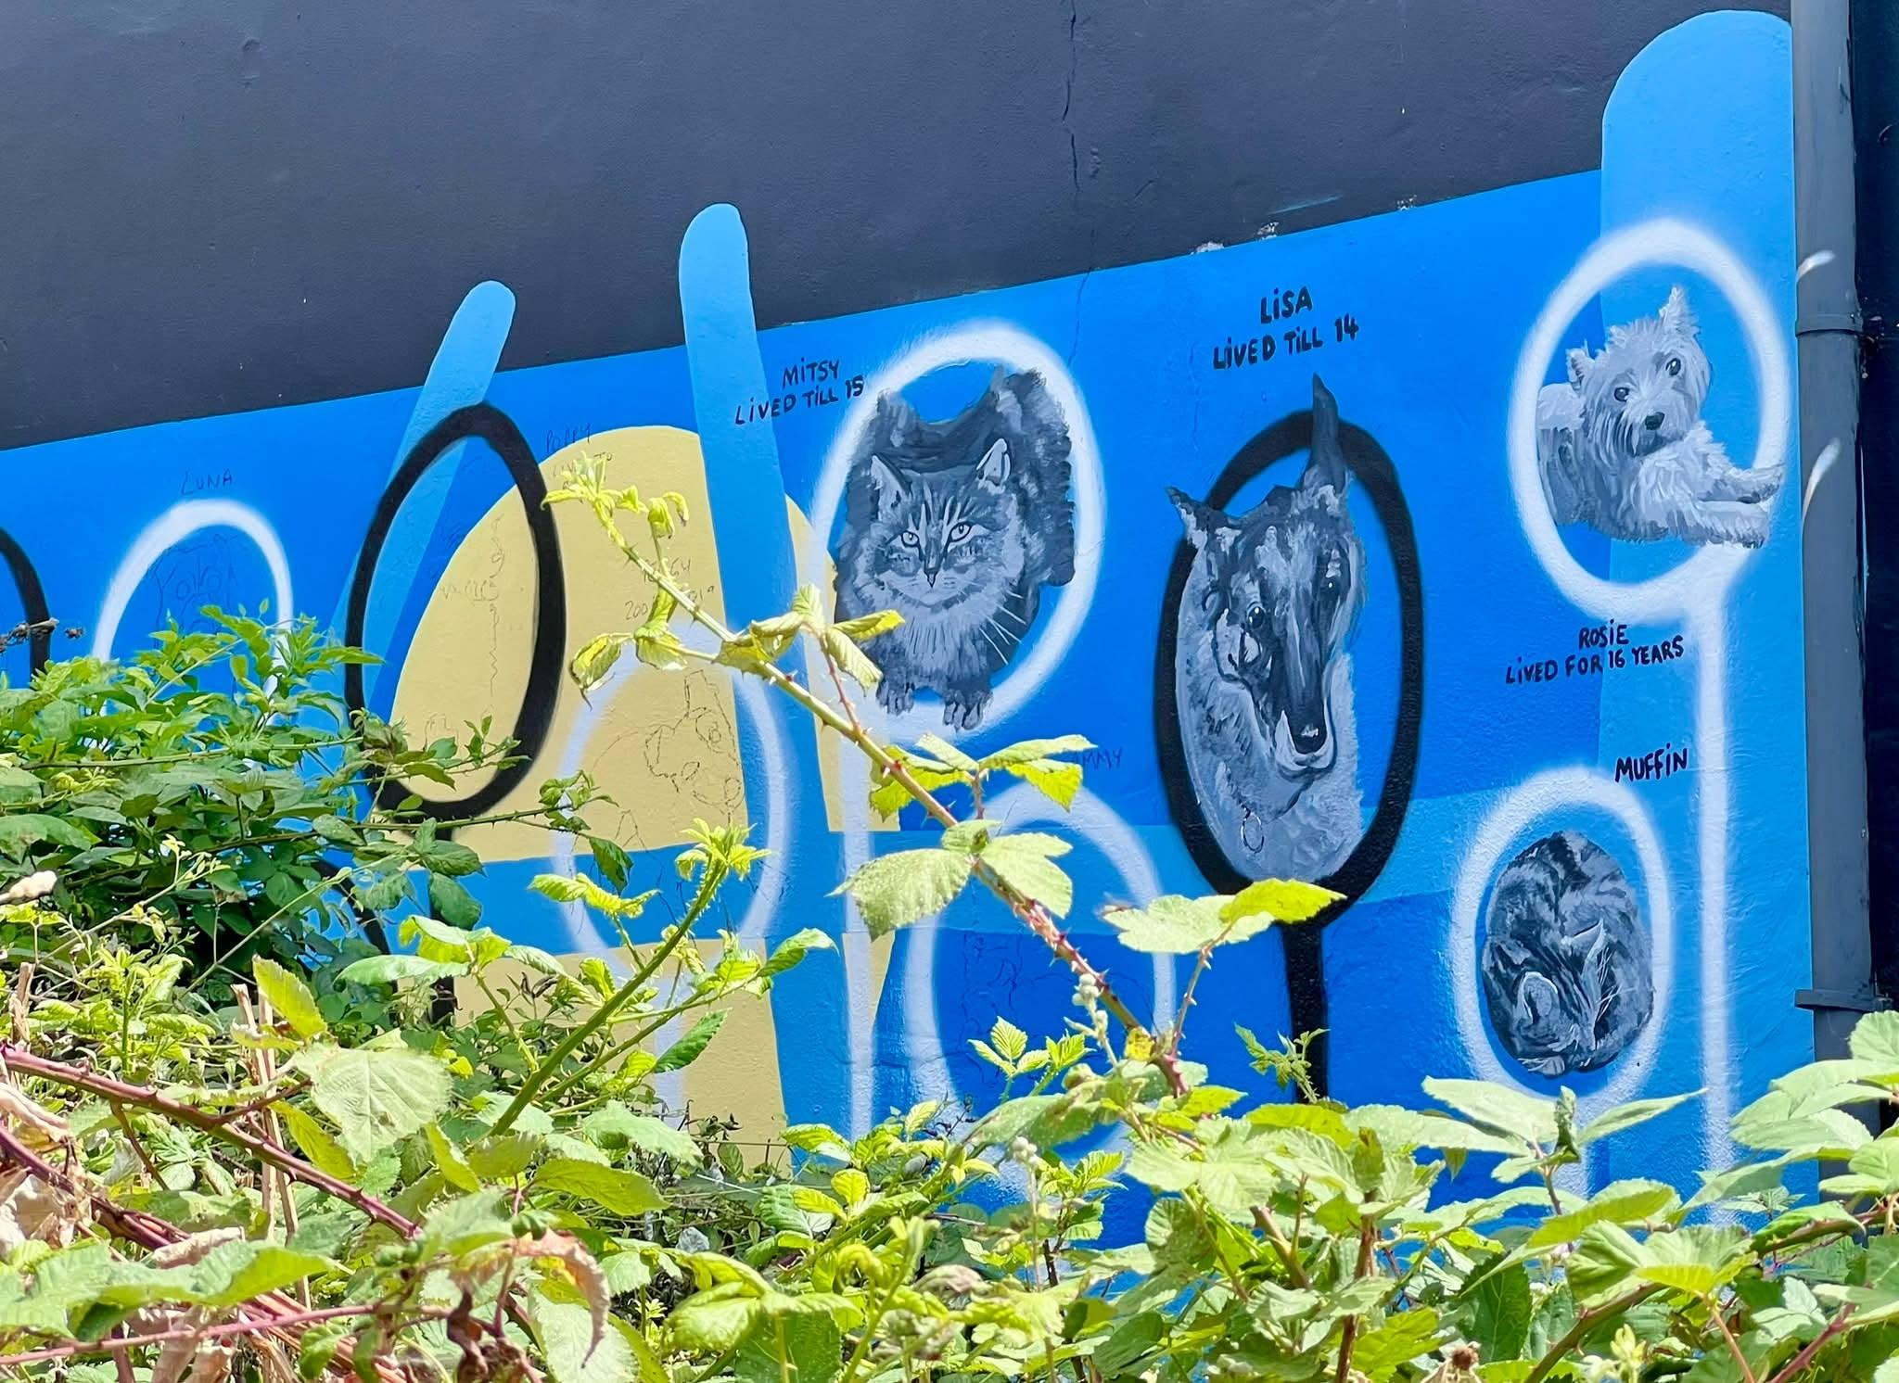

DAY SIX(ish) WITH THE BRUSH:
It hasn’t rained for weeks, right?
The moment I step out and begin painting little Peggy, a passer by pointed me out to her daughter “look an artist is painting over there” … the heavens opened.
It’s now raining cats and dogs in Gloucester. Not in a good way.
Abort mission. Hoping Peggy hasn’t been washed down the wall

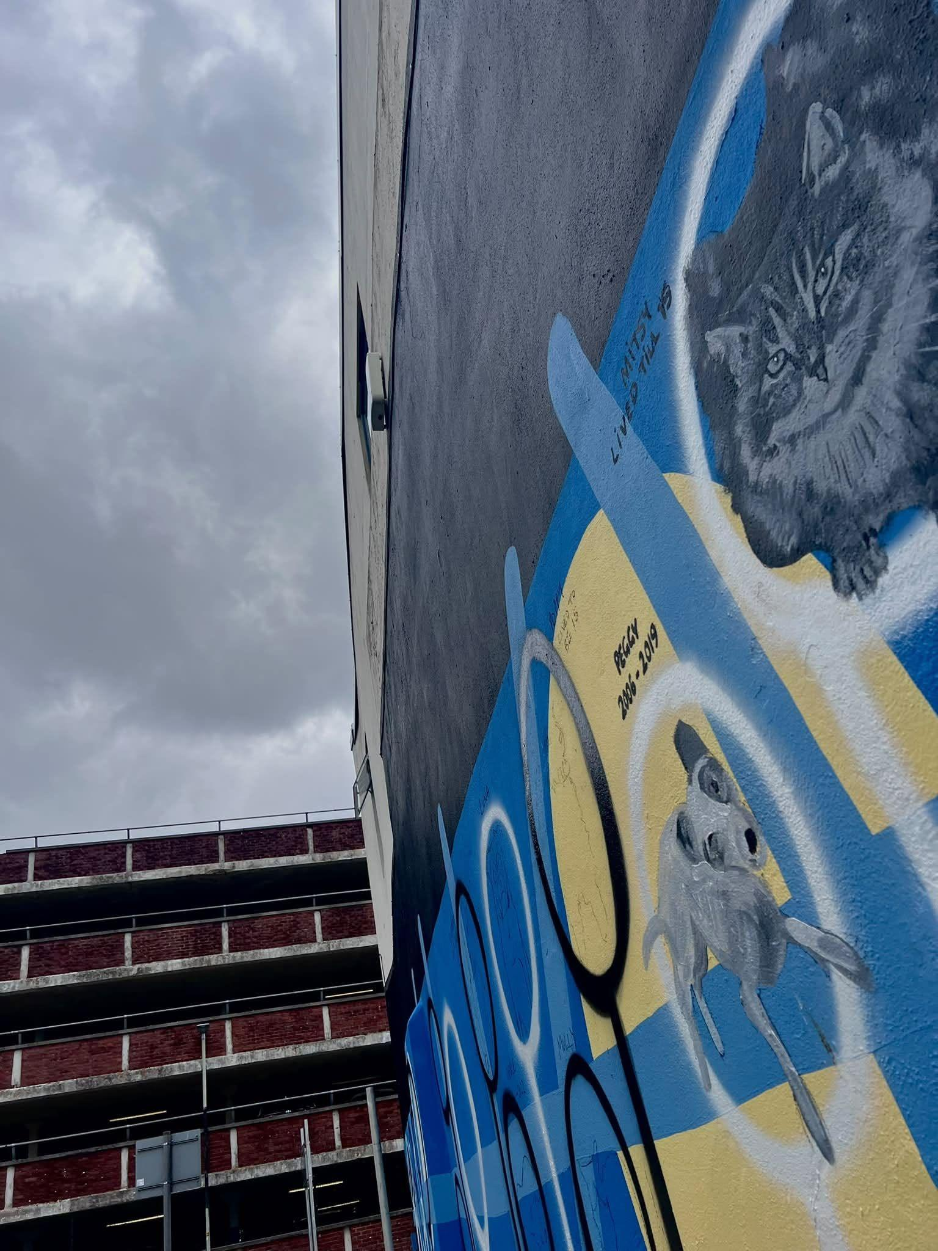

DAY SEVEN WITH THE BRUSH:
I’m still painting pets for the big “thank you wall” for the Man Who Fed the Cats mural project funded by Voices Gloucester
11 of 34 pets have now been painted. Feel like I should get sponsored per pet! #paintathon - any donations you want to make to Teckels Animal Sanctuary in memory of Ralph Fletcher go right ahead!
Today on the street someone found me hiding in the bushes painting in solitude. A man waiting for his mobility scooter to be fixed made his way over to chat to me. Supported by the railing he told me all about the dogs he had owned and his love of rhinos! He got charged by one once and had seen them in the wild in Africa. He has even changed his will recently to give to the rhinos. He has promised to come back to see the finished mural. I might sneak in a baby rhino just for him.
#mural #gloucester #apicturepaintsathousandwords #murmurartist Love Gloucestershire
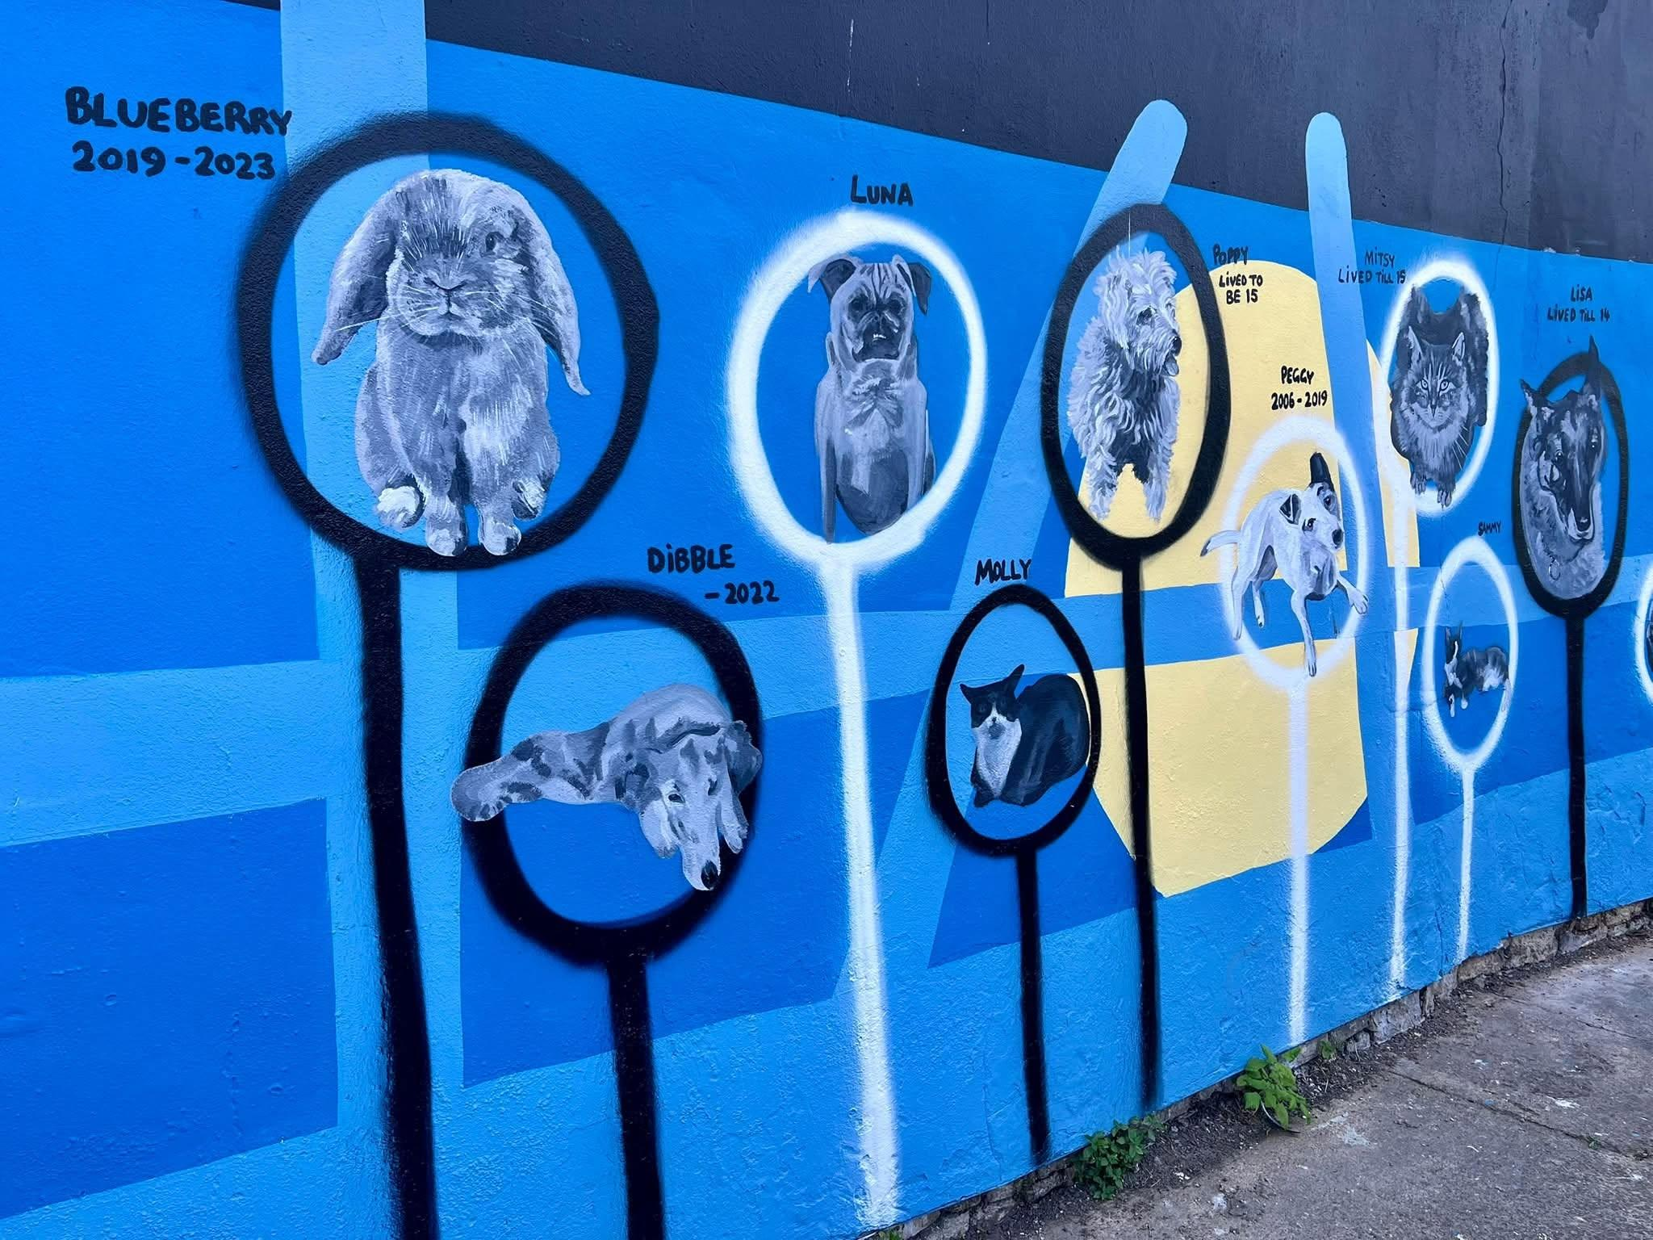

DAY EIGHT WITH THE CHARCOAL:
Very early on Sunday morning I snuck out to outline sketch out the remaining 21 pet portraits. Not the fun of usual visits to the wall. I had to clear the site of needles, burnt spoons and other drug paraphernalia first. I encountered nobody as I drew. All was quiet.
Once finished, an ambulance showed up to attend to one of poor tormented souls who live in the multi-storey car park next door. I focussed on the kindness and compassion of the paramedics and white butterflies danced over the fruiting brambles nearby.
#mural #murmurwallart

DAY NINE WITH THE BRUSH:
An early shift on “The Man Who Fed the Cats” mural in Gloucester city centre. Trying to beat the heat.
Today at the wall I painted Hamish; Makhaya Ntini; Scooby and Otis. This is a picture of Otis in progress - painted as a man with a long pony tail stood close behind me saying, “I have literally never seen anyone painting before”. Made me realise how performative painting a mural is. Not my comfort zone really, but maybe I’m a secret show off.
Earlier lots of uniformed workers with lanyards hurried to their jobs. One nurse was carrying a big cake in a box. The traffic wardens were in very good spirits and said they had seen the sister mural in Arthur Street. The male said that Hamish looked like his cat that his granddaughter liked to draw. I said I thought I hadn’t done a brilliant job of Hamish and was worried about it. They laughed and said they would return.
My lovely neighbour happened past and we caught up. Good to have a break, or I keep going till I crash.
Building up my courage to paint a horse tomorrow. Wish me luck.

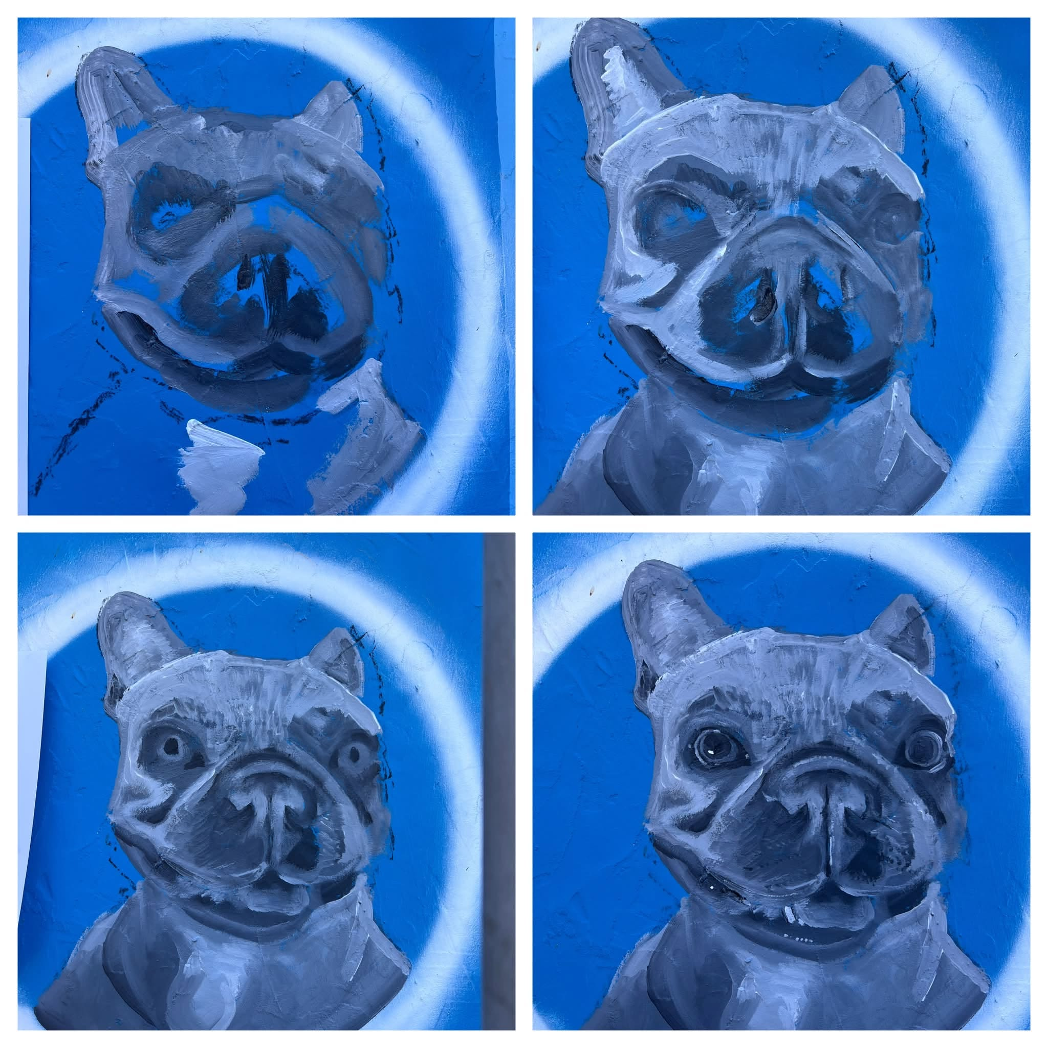

DAY TEN WITH THE BRUSH: Here is what happened at the wall today:
A very early start to avoid the heat and the crowds. Yes crowds! By ten o’clock I had a bunch of people watching me paint. Asking for my photo. Absolutely not. NOBODY must know who I am. I move in the shadows, right?
I ended up giving a mini lecture about former mayor of Gloucester Ralph Fletcher, and why I was painting the mural, which was simultaneously translated into Italian for some tourists.
Several people spent A LONG time watching me paint and enjoying hearing stories about the animals already done. Children chose their favourite ones. Am I becoming a school holiday experience? What’s going on?
I met a lovely lady and her partner named Fletcher (no relation sadly) who showed me pictures of his rescue dog, called Seven (now sadly passed). He took the dog to ancient churches, but he disliked people.
 Someone shouted “has anyone ever told you, you are amazing?” The lovely lady said “yes! I just did!” Honestly.
It was all a bit much for me. I began to feel a bit like Seven the dog and longed for the cool of an ancient church and no people.
Still, despite the humans, I managed to paint Beau the horse; Dotty the dog; and three cats - Kylo, Sprockett, and Dave.
More from the wall tomorrow. Do feel free to visit - but not in coach loads. And no photos!
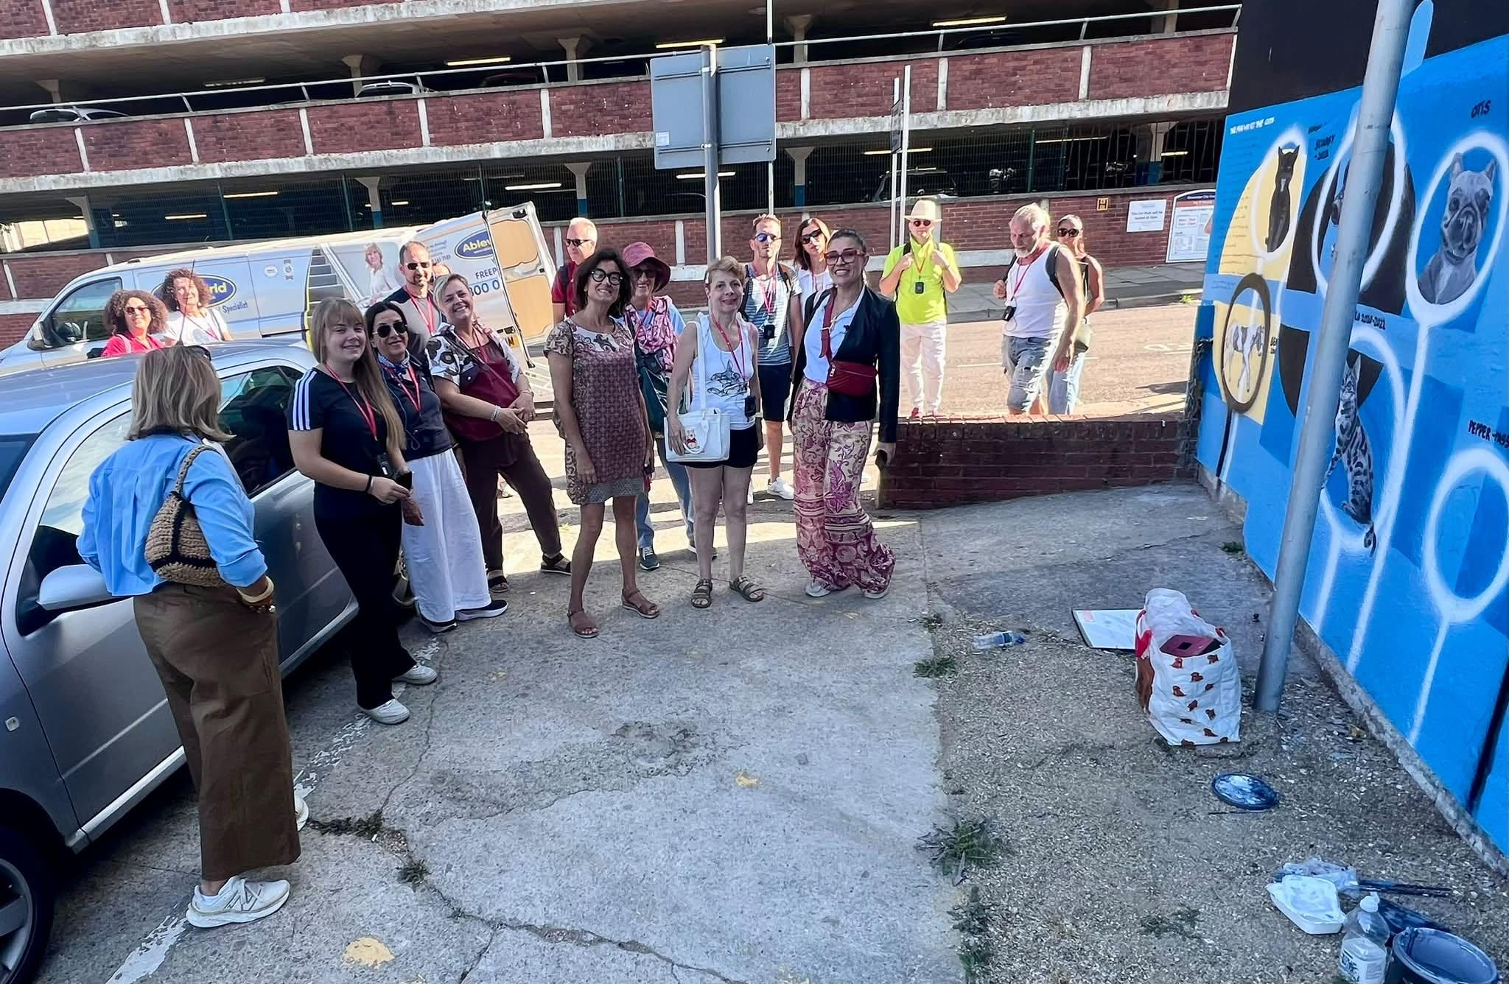
DAY ELEVEN WITH THE PAINTBRUSH on the Gloucester mural "The Man Who Fed the Cats" funded by Voices Gloucester . Today at the wall:
Spoofie, Crunchie and Ben joined the wall of 32 much loved pets (still have 9 to paint).
I had further chats with the traffic warden and lots more questions from passers by. People are proper stopping now and taking time with the wall, even if they are on their way to work.
Bumped into an artist friends who volunteers for the animal charity Teckels. The wall features at least one of her dogs. She is joining us on 13th September for a mini mural launch. If everyone who has stopped already turns up - we are in for a huge crowd.
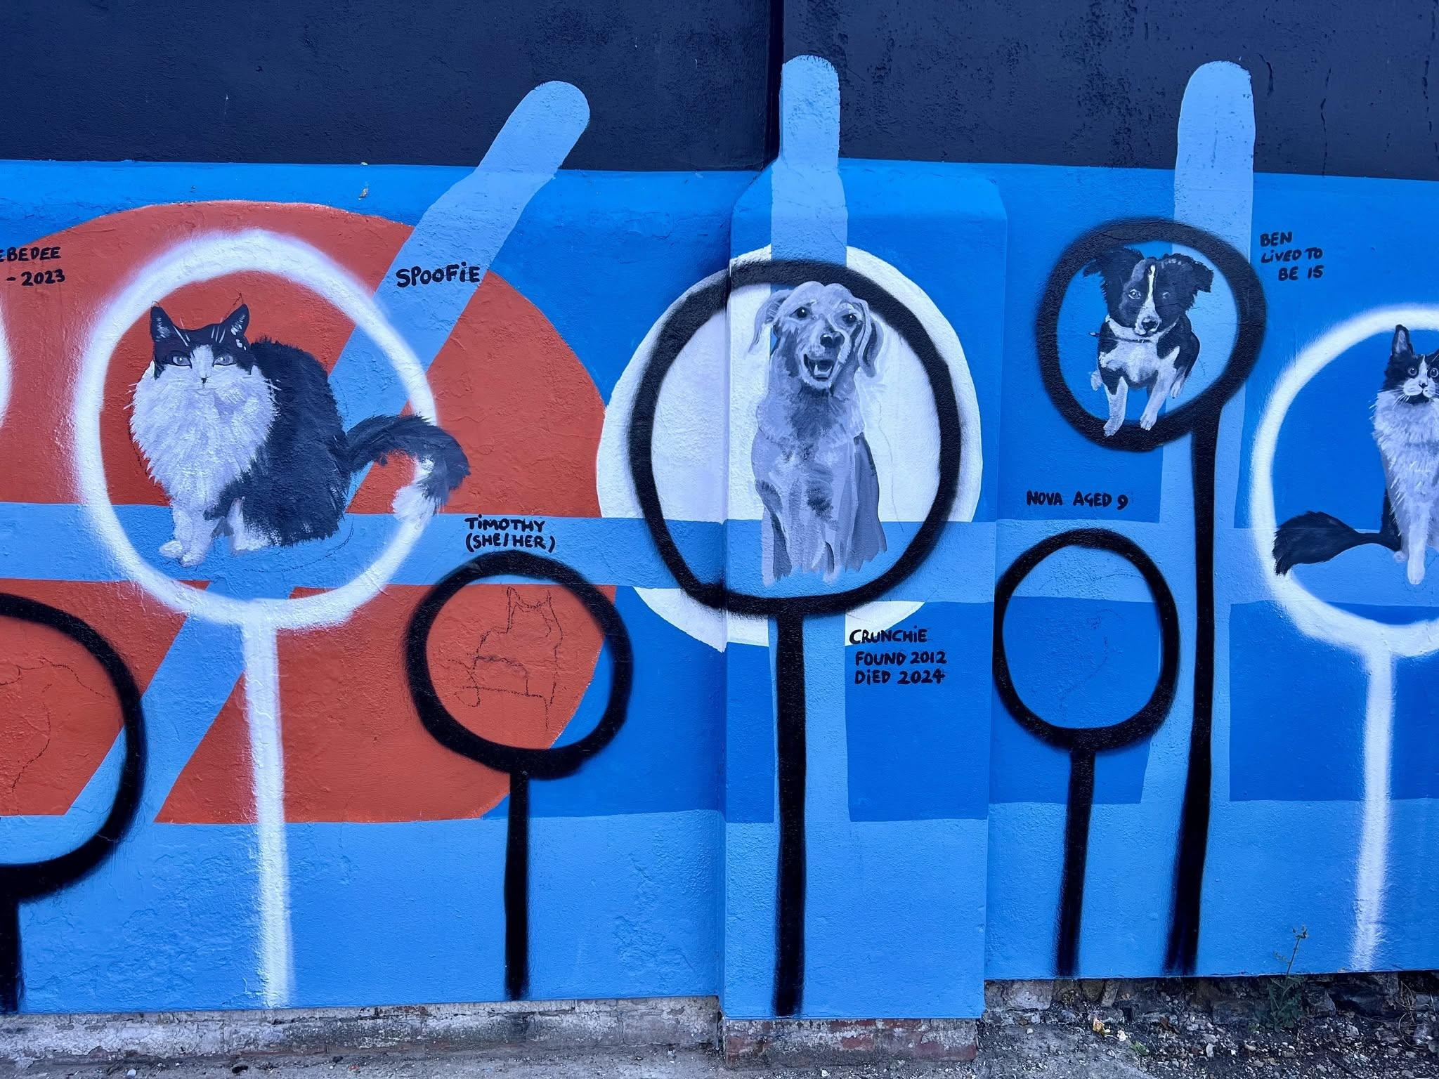

I’m probably the only person in Gloucestershire hoping it doesn’t rain right now. I managed to be at the Gloucester city wall at 6am today for DAY TWELVE WITH THE BRUSH on the Voices Gloucester mural… but clouds are gathering and I’ve only managed to add 3 pet doggies to the wall. The traffic warden stopped by to say she wished she could do art. She feels like an old friend now. I’ll be thinking of her in the rain, as I clean my brushes.

DAY THIRTEEN WITH THE PAINT BRUSH. Just two little fellows added to the wall today. And no, I’ve never painted a tortoise before.
Today at the “Man who Fed the cats” mural in Gloucester we were joined by a handful of tourists. Some from Australia even. They took photos and I said I was so glad they had chosen to visit Gloucester. They were off to the Cathedral and said they were a dog and cat family. Same.
One lady stopped and said she had a cat, but couldn’t read the explanation of the mural, so I talked her through it. She said it was a lovely idea.
My favourite traffic warden came by to look at progress and again said she wished she could paint. Like anything - you just need to practice over and over before you get good. Honestly I need a few hundred more tortoises under my belt before I start selling tortoise pet portraits

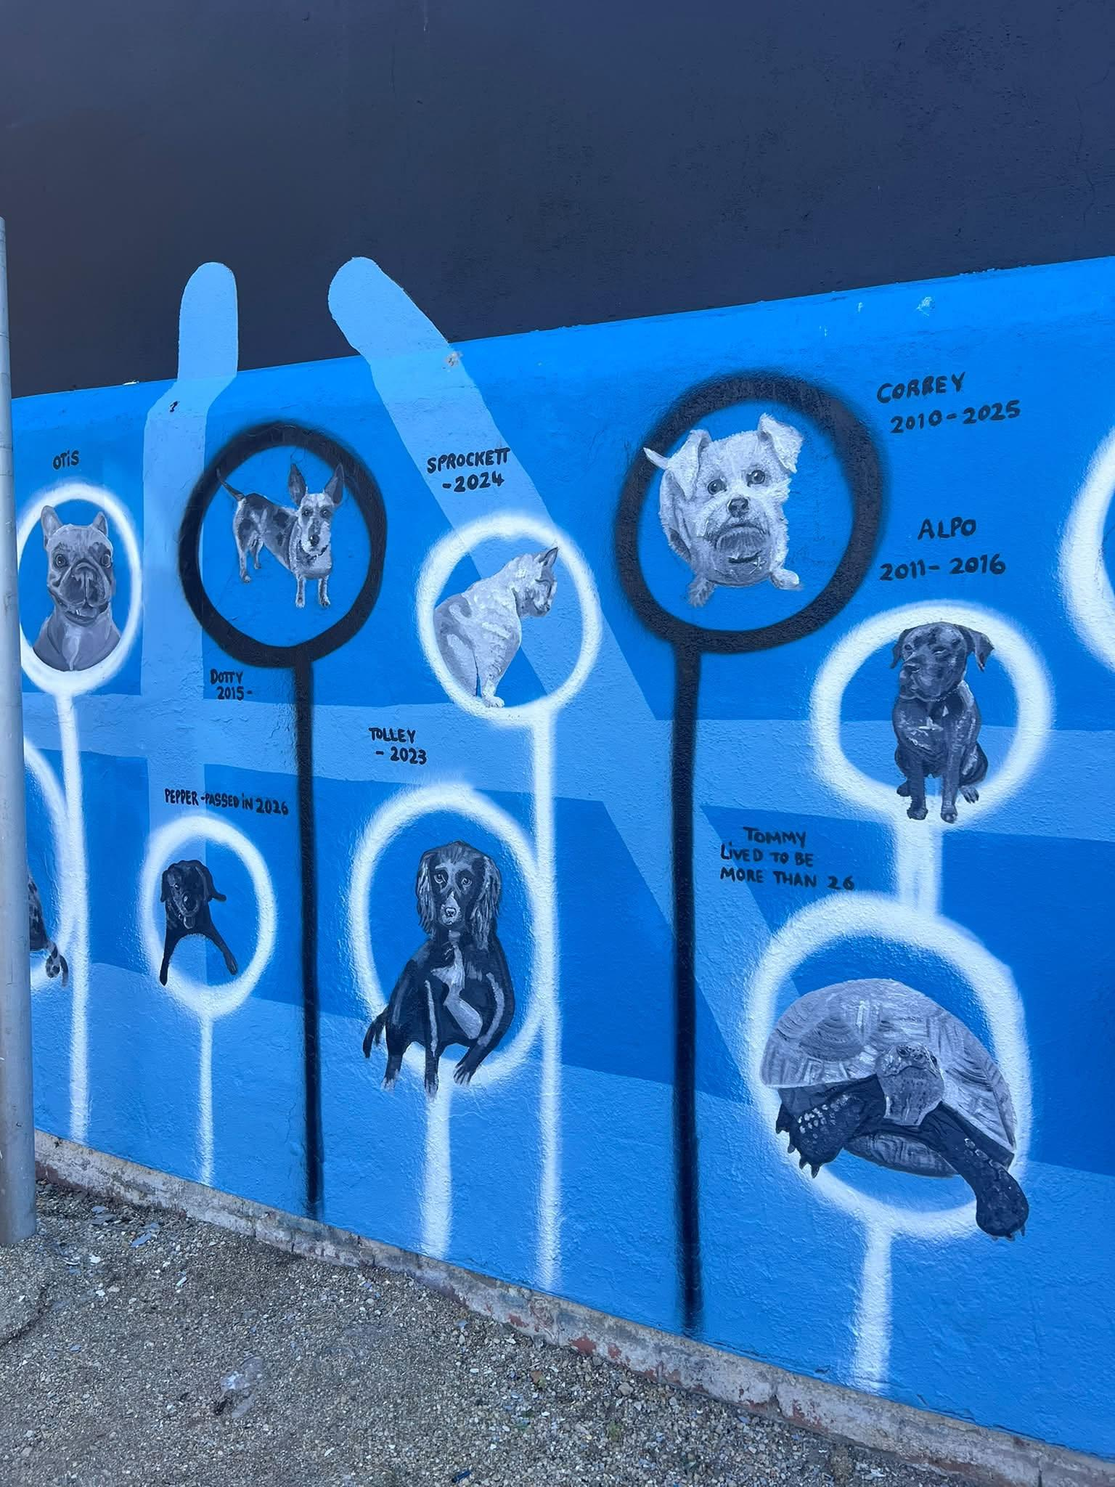
LAST DAY WITH THE BRUSH! Today I finished that second and last “Man Who Fed the Cats” mural. What an almighty mission. Thanks to Westbourne Care Home Voices Gloucester BBC Gloucestershire my painting assistants, Gloucestershire Heritage Hub those who helped me with research, Adrian Graham, the passers by who stopped for a chat, and everyone who allowed me to share their special pet. Big love

